Miércoles 20 de enero
Vídeo: https://youtu.be/qiFnZgWRfAg

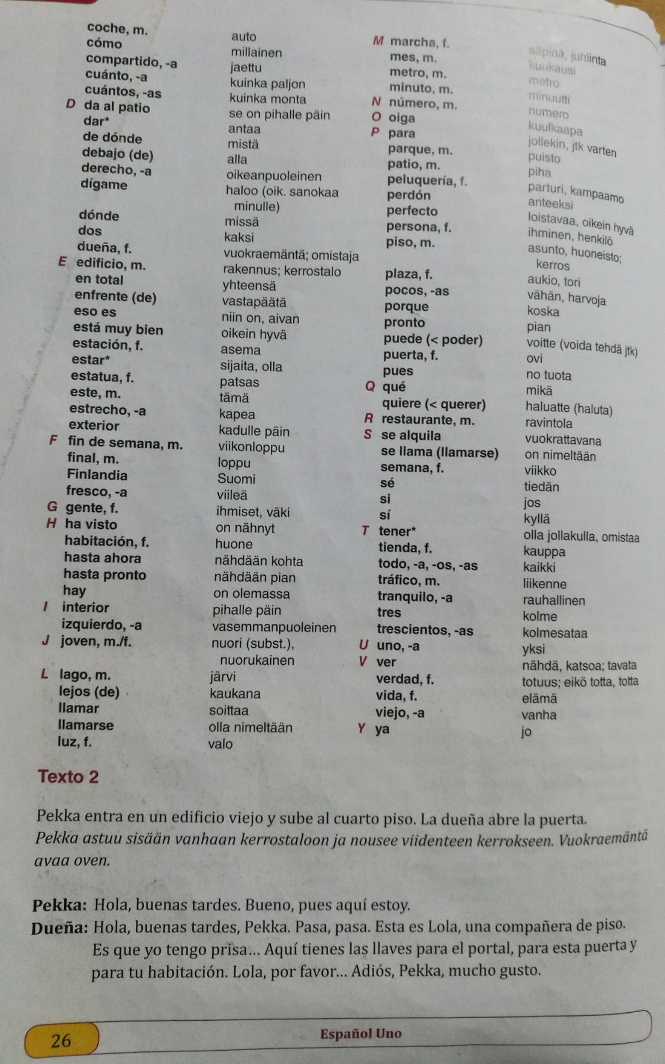
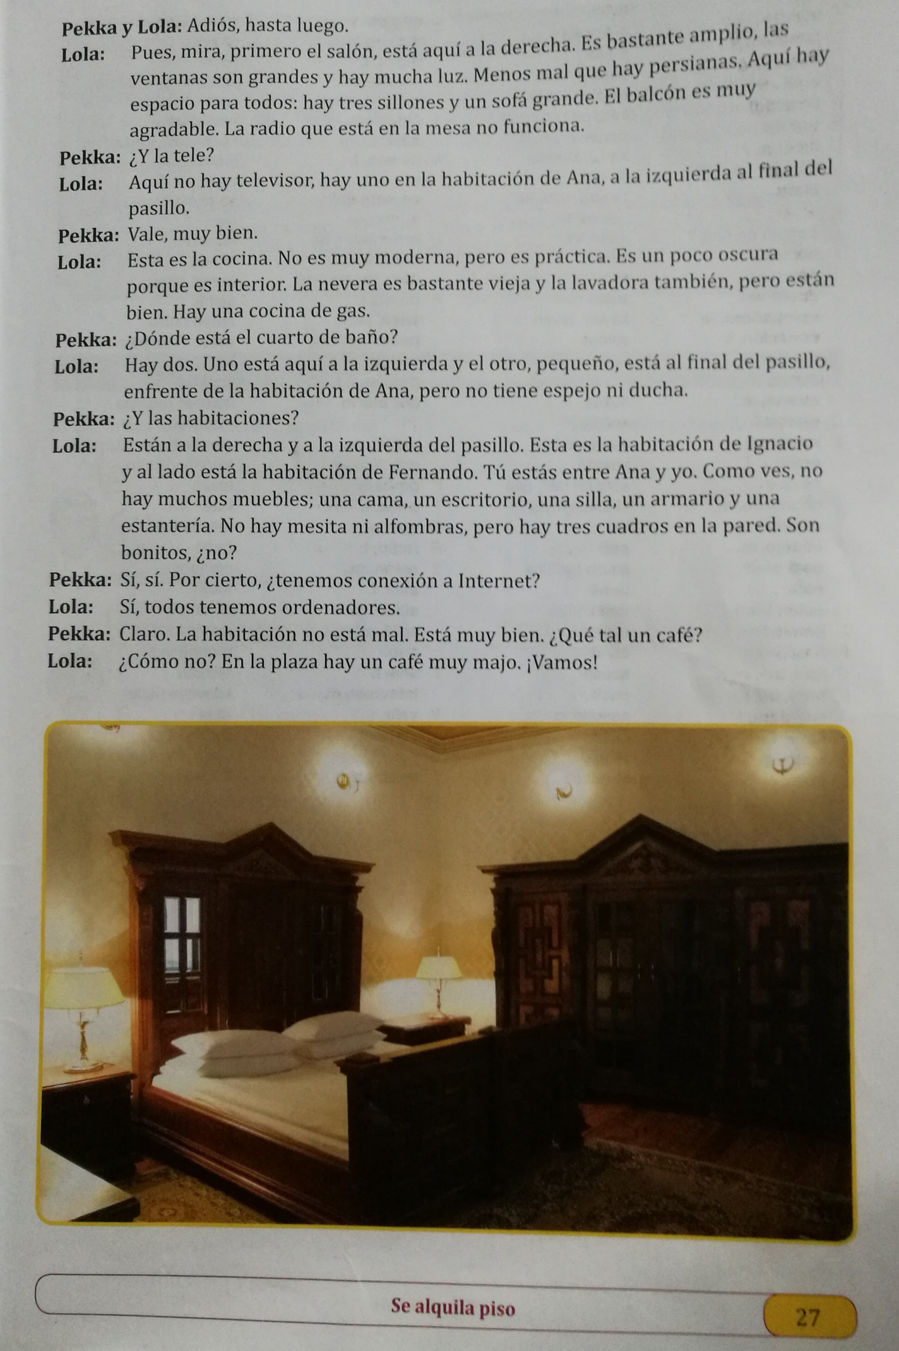
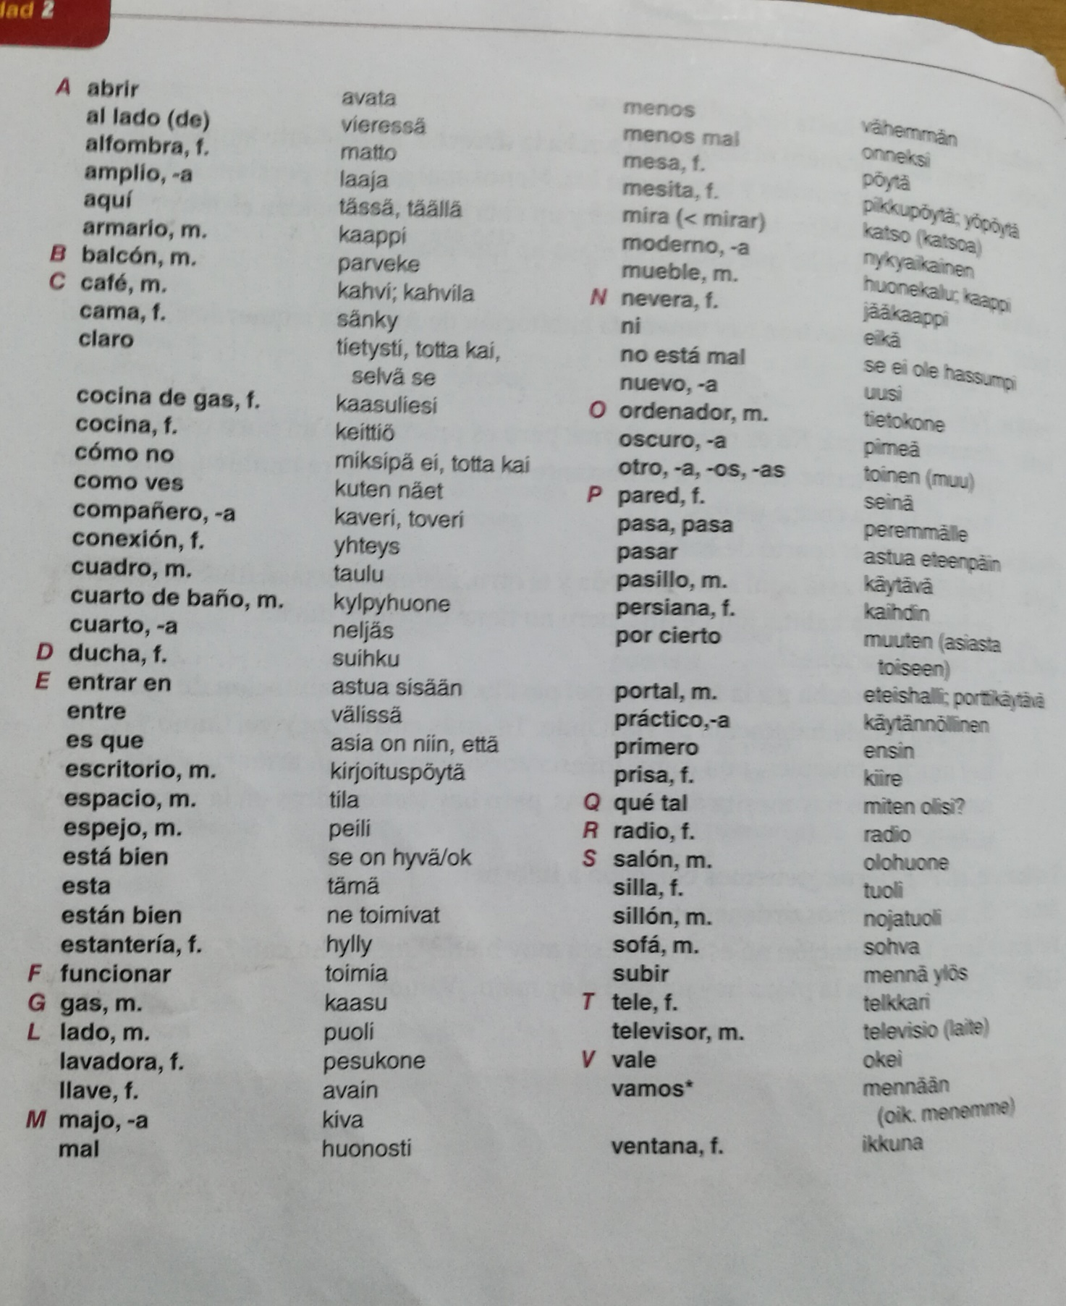

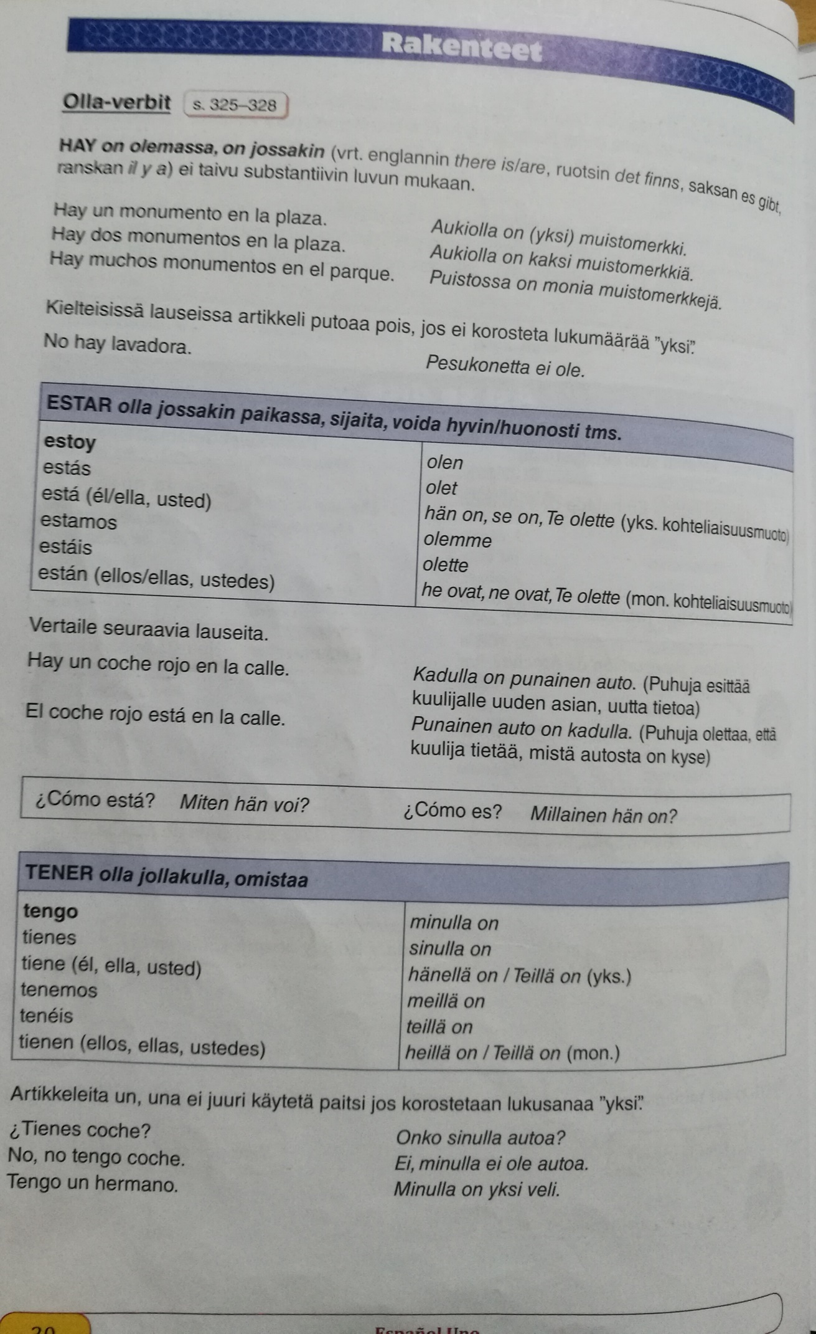
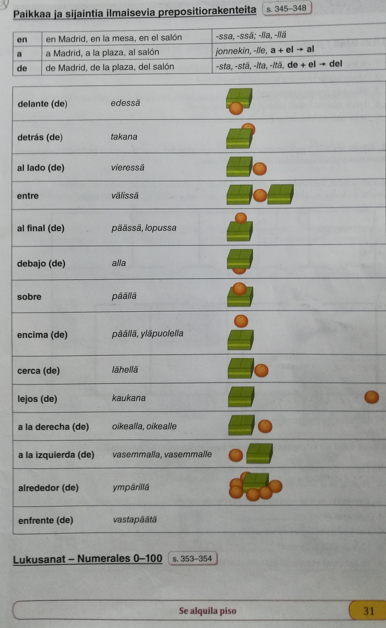
HABLAR COMER VIVIR
Hablo Como Vivo
Hablas Comes Vives
Habla Come Vive
Hablamos Comemos Vivimos
Habláis Coméis Vivís
Hablan Comen Viven

ENTRAR BEBER SUBIR - ABRIR

TAREA PARA EL LUNES 25 DE ENERO
Ejercicio 9, páginas 34 y 35
Ejercicio 15, página 37
Enviar a: lopez.semiotics@protonmail.com
Subject: Cap. 2

Very useful site:
https://studyspanish.com/grammar

Flashcards:
https://studyspanish.com/verb-flashcards
Uses of SER
the hour, day, and date
place of origin
occupation
nationality
religious or political affiliation
the material something is made of
possession
relationship of one person to another
certain impersonal expressions
where an event is taking place
essential qualities

Uses of ESTAR
geographic or physical location
state or condition
many idiomatic expressions
progressive tenses

SER and ESTAR (contrasting uses)
When a noun follows the verb, use ser
When an adjective follows the verb, decide between “essence” and “condition”
To tell where something is from, use ser
To tell where something is located right now, use estar
To tell where an event is taking place, use ser

HAY
there is, there are

