Lunes 18 de enero
Videos:
https://youtu.be/0LduSXbp9kA
https://youtu.be/Gko-31UKXDM
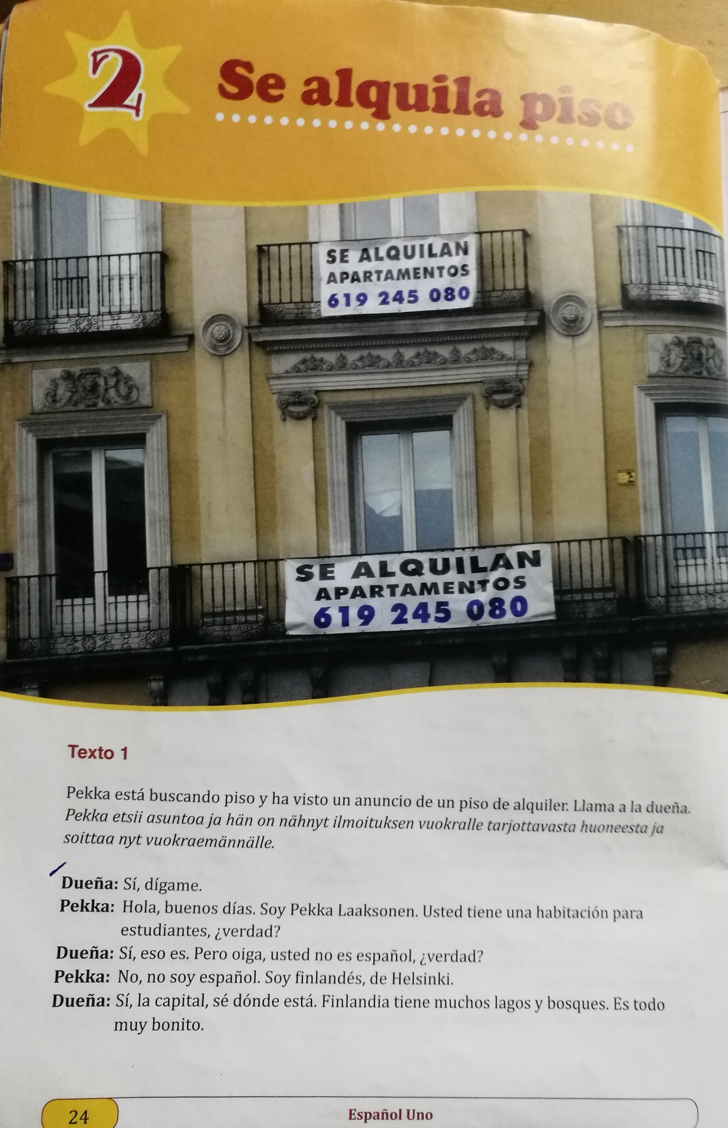
Madrid es la capital de España SER
Madrid está en España ESTAR
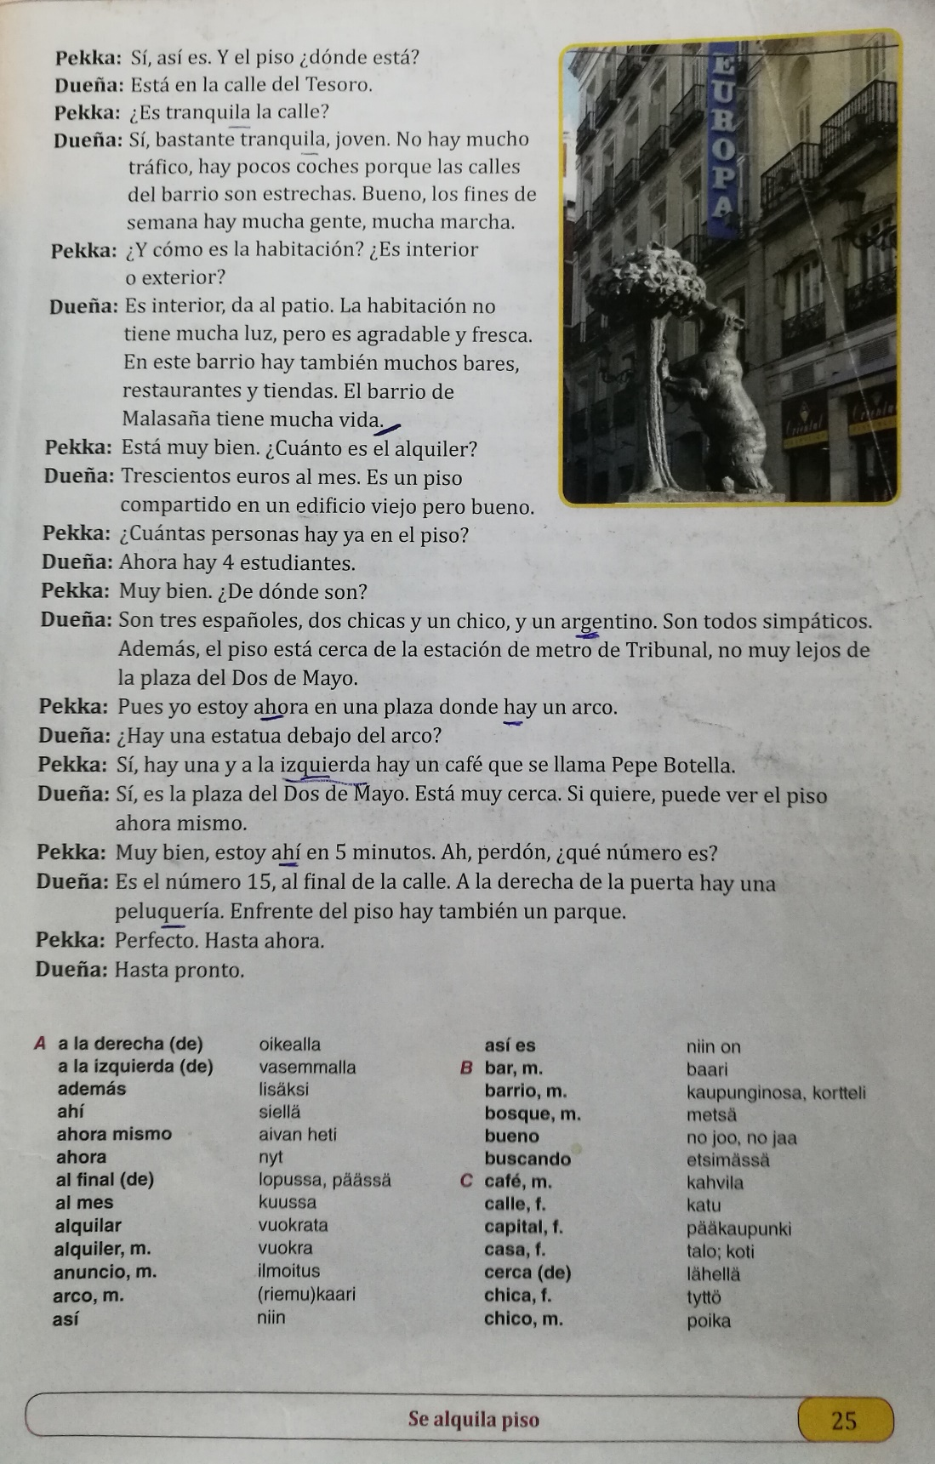

a + el al
de + el del
a + la = a la
de + la = de la

CUATRO 4
QUATRO
La zanahoria

¿De dónde eres?
Soy de Tampere
Soy de Hevonperse
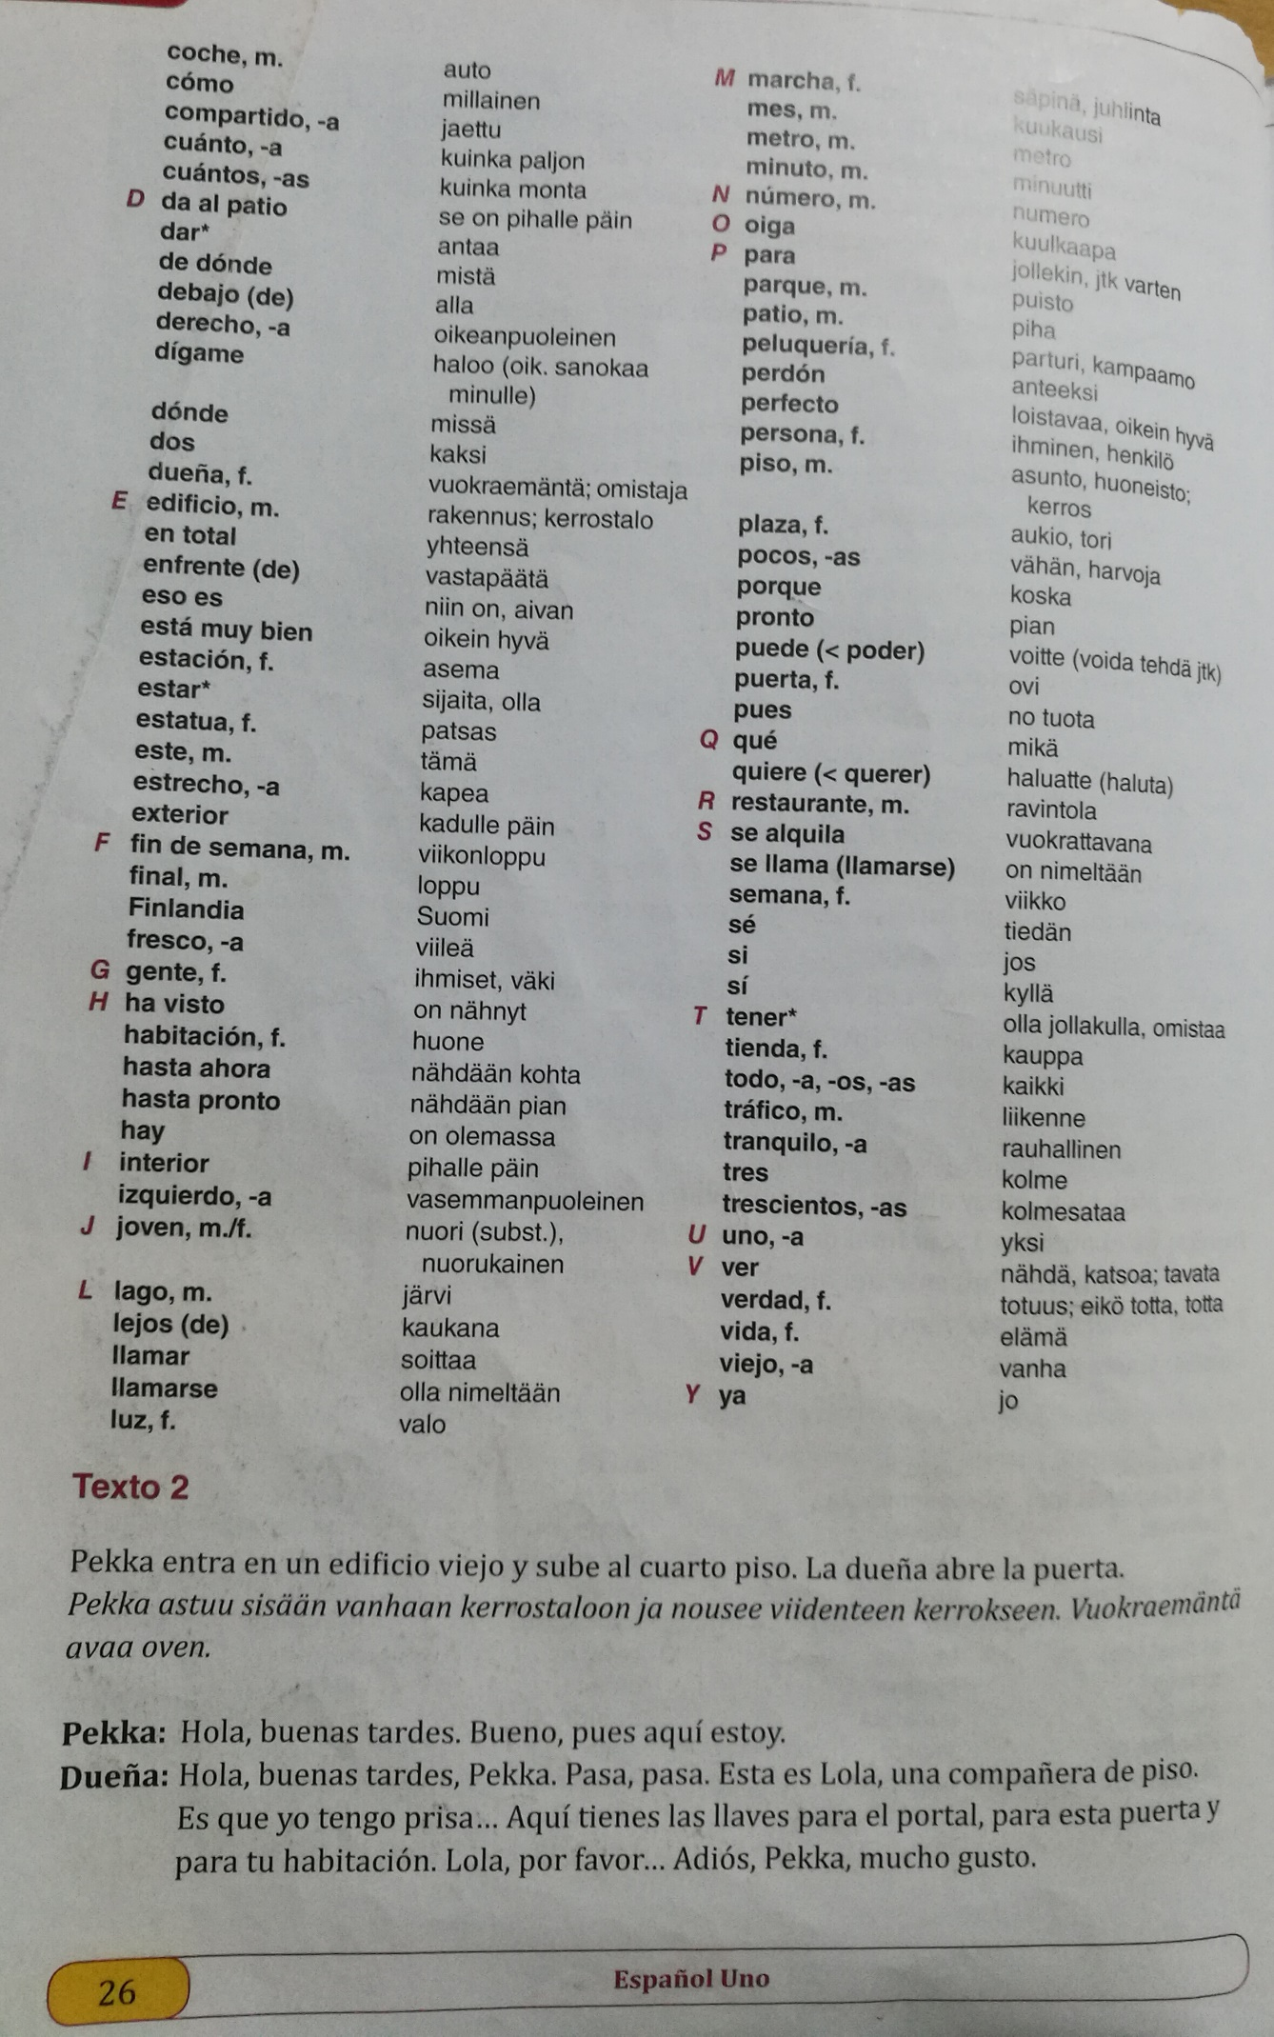
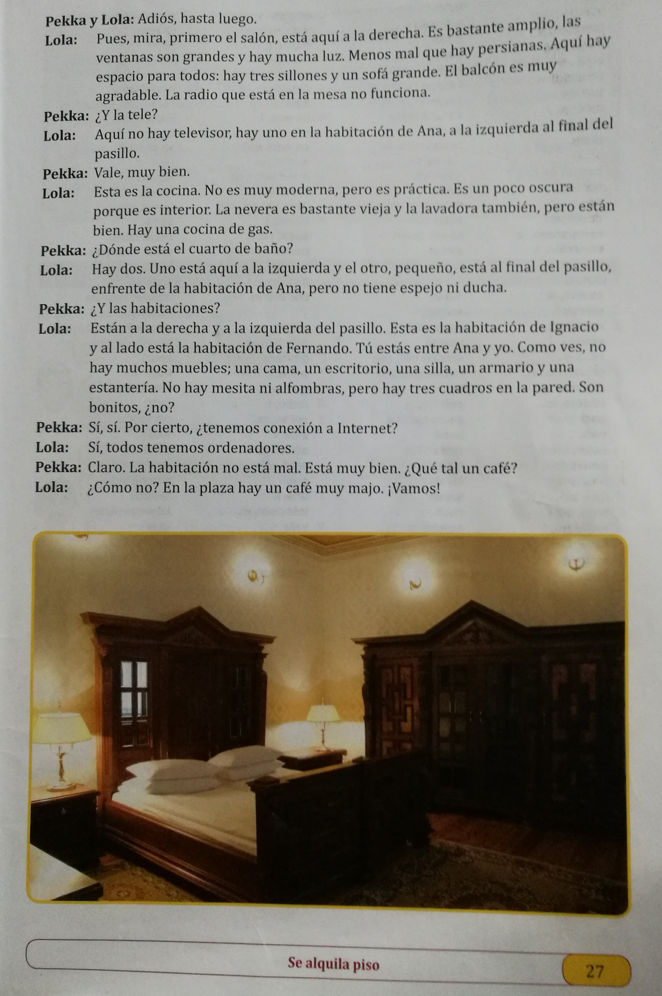
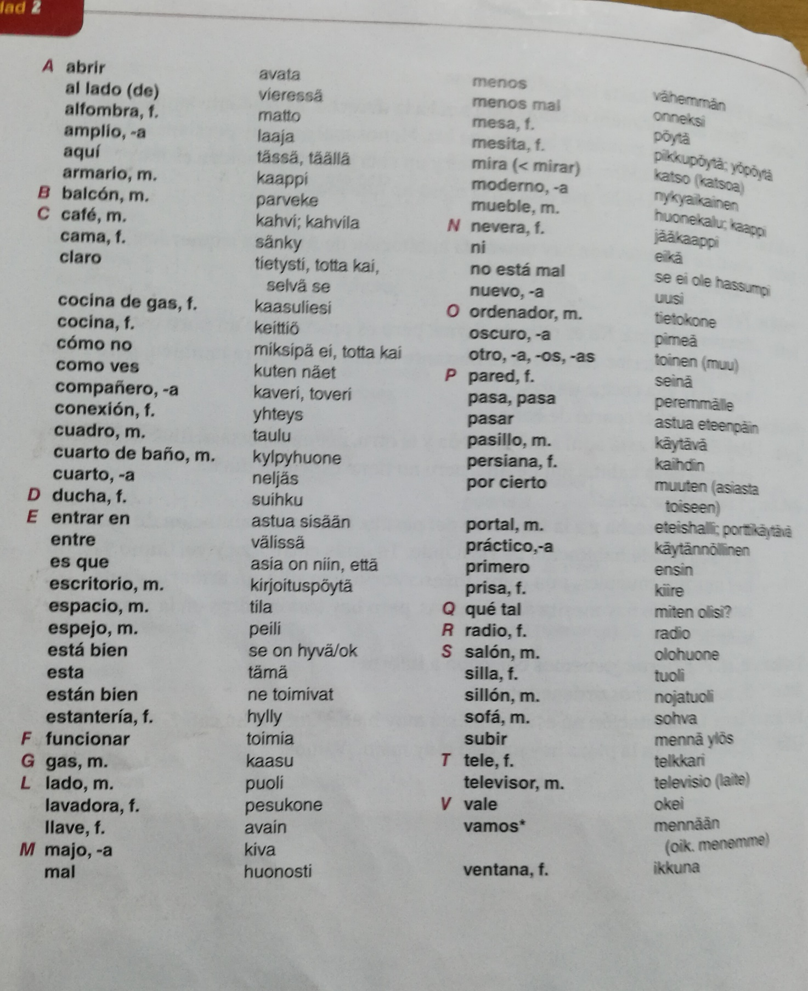

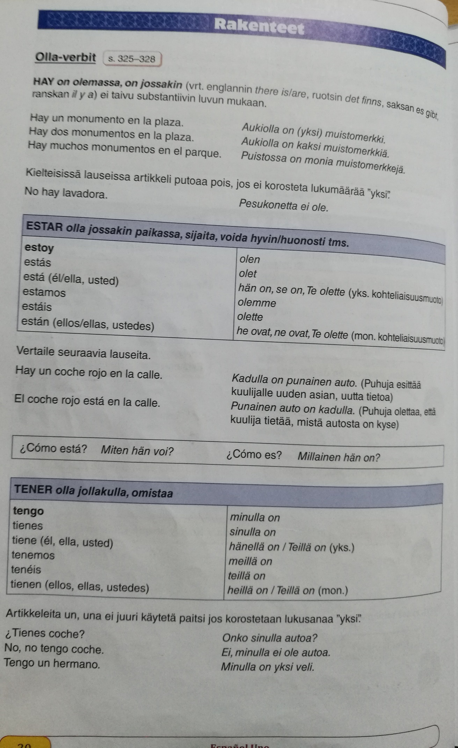
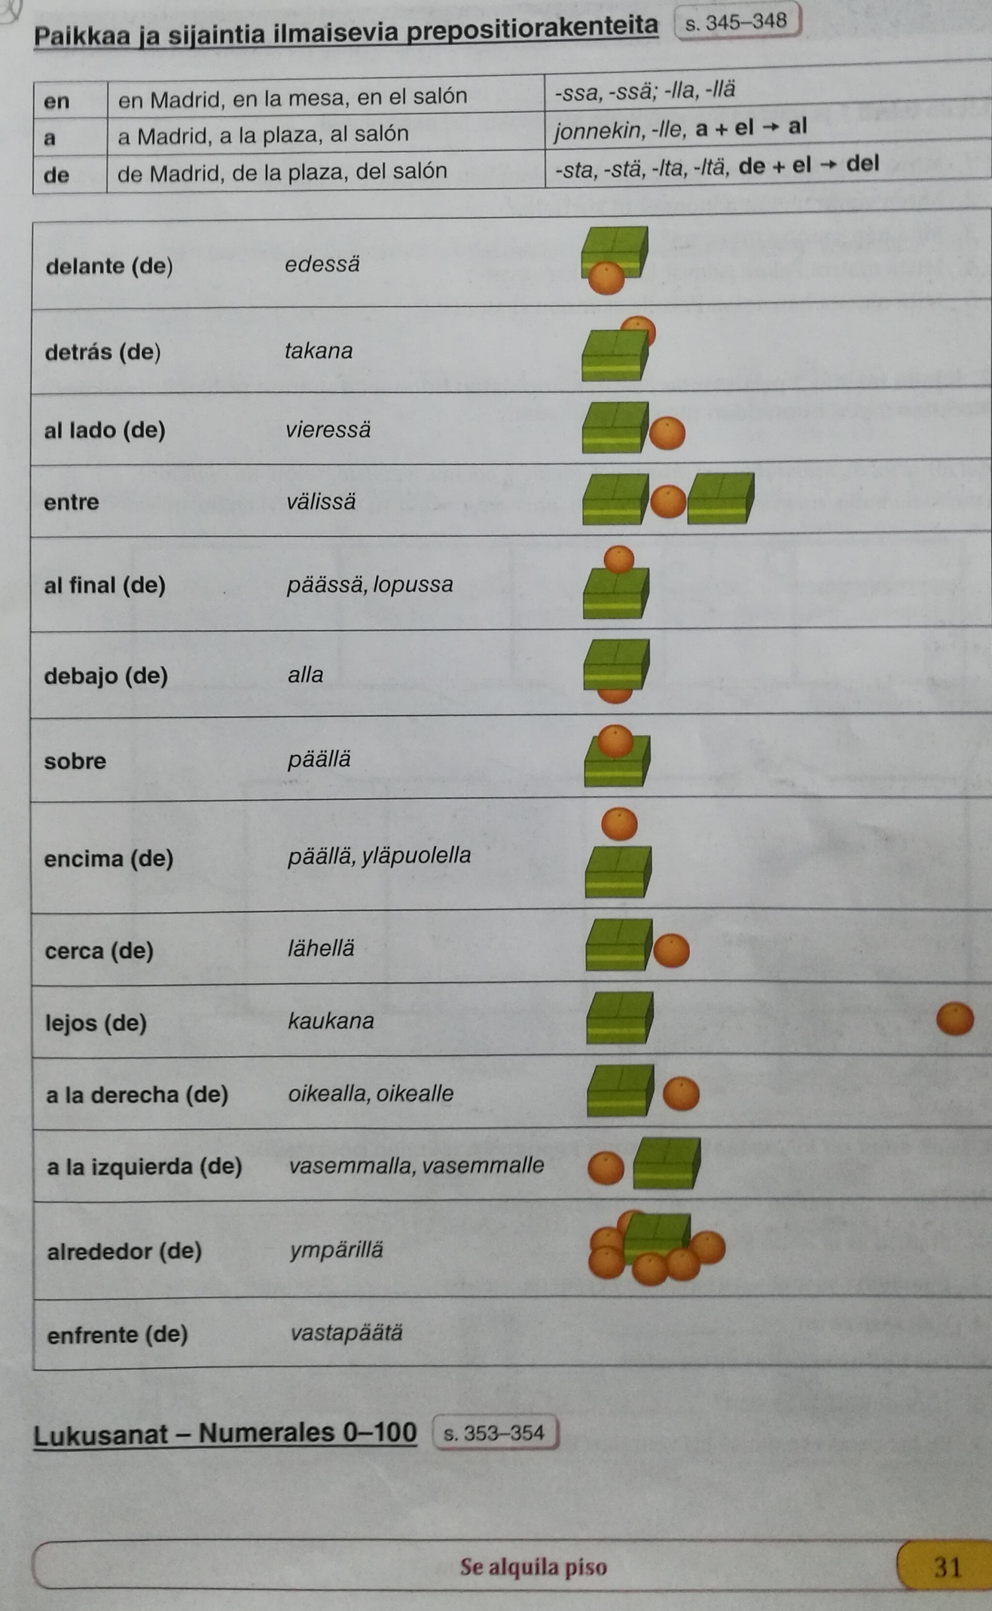
Esta dirección electrónica para el CHECKPOINT #5
miguel.lopez.finland@gmail.com
Asia/Subject/Asunto: Obra de arte
La pelota está sobre la casa
La pelota está debajo de la casa
La pelota está detrás de la casa

Very useful site:
https://studyspanish.com/grammar

Flashcards:
https://studyspanish.com/verb-flashcards
Uses of SER
the hour, day, and date
place of origin
occupation
nationality
religious or political affiliation
the material something is made of
possession
relationship of one person to another
certain impersonal expressions
where an event is taking place
essential qualities

Uses of ESTAR
geographic or physical location
state or condition
many idiomatic expressions
progressive tenses

SER and ESTAR (contrasting uses)
When a noun follows the verb, use ser
When an adjective follows the verb, decide between “essence” and “condition”
To tell where something is from, use ser
To tell where something is located right now, use estar
To tell where an event is taking place, use ser

HAY
there is, there are

