TIES 4520 (2024): Guidelines for the Task 3
Your surname:
Your first name:

Task 3-1: Underneath you see a graphical representation of the TBox part of an ontology. Please write it in Turtle notation using RDF Schema as the ontology language.
Namespaces are defined as following:
@prefix u: <http://www.jyu.fi/ontology#> .
@prefix rdfs: <http://www.w3.org/2000/01/rdf-schema#> .
@prefix xsd: <http://www.w3.org/2001/XMLSchema#> .
@prefix rdf: <http://www.w3.org/1999/02/22-rdf-syntax-ns#> .

Class hierarchy:
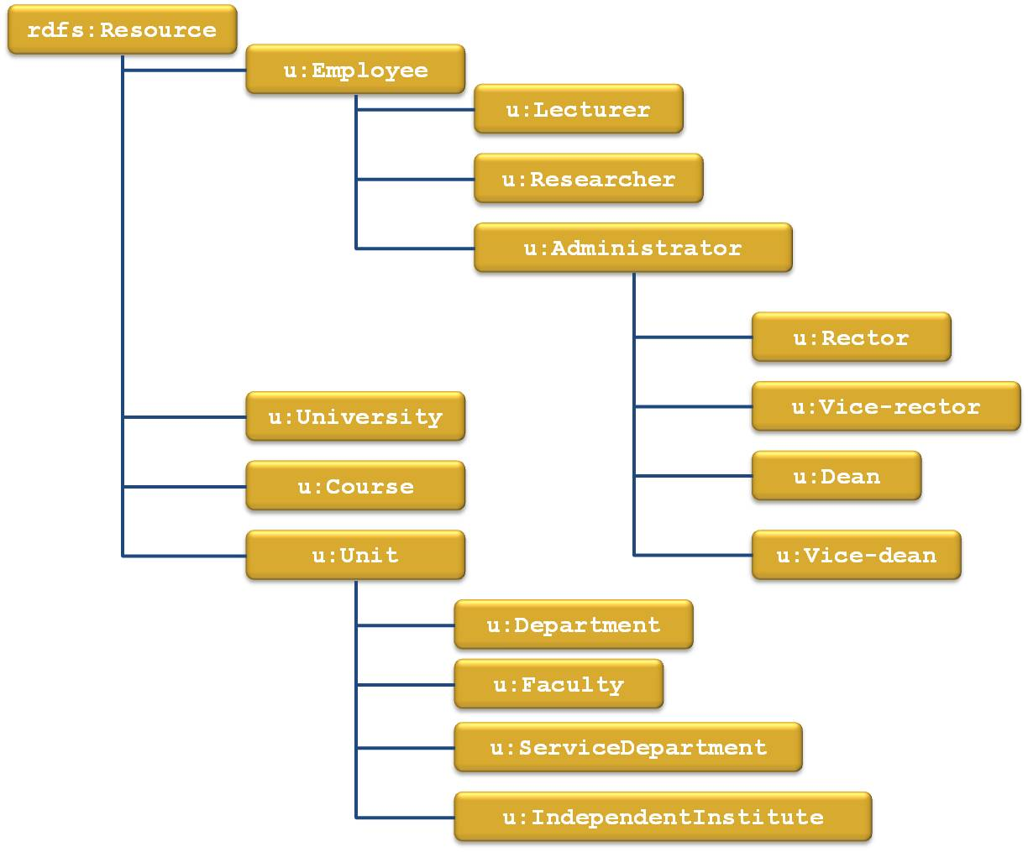

Properties (no hierarchy, all at the same level):
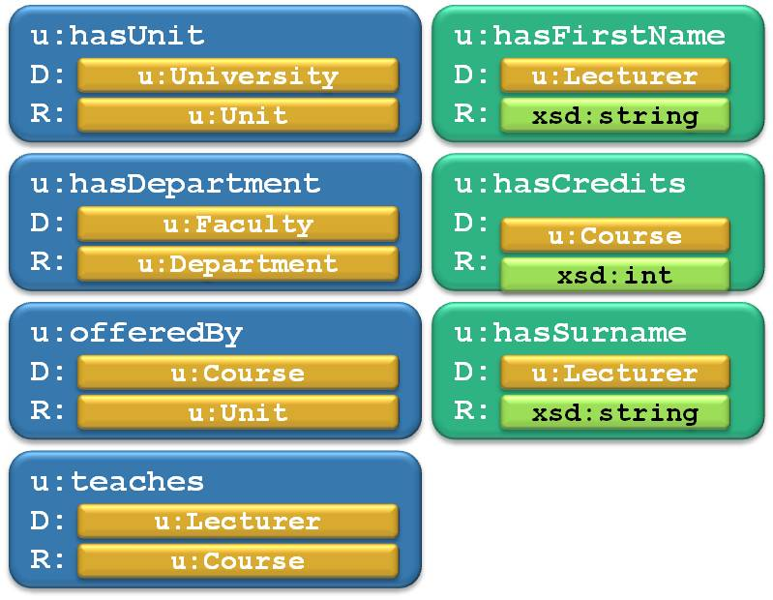

Your solution in Turtle:

Task 3-2: Below you can see an ontology written in RDFS. It contains both ABox and TBox. Underneath there are several statements written in a table. For each statement decide if it is correct according to the ontology or not. If the statement is correct, put X in the correct column. If it is incorrect, put X in the incorrect folder. Prefixes and namespace in the table are defined the same as in the ontology text area Ontology in Turtle.
Let’s assume that there is a reasoner that would detect hidden relationships, e.g. class-subclass relationship. Therefore, take into account also derived statements, even though they are not explicitly defined.
Important: Your task is not to decide if the statement has sense or not. Your task is to decide if the statement is formally correct according to the ontology.

Ontology in Turtle:
@prefix z: <http://zoo.com/animalOntology.rdfs#> .
@prefix rdfs: <http://www.w3.org/2000/01/rdf-schema#> .
@prefix xsd: <http://www.w3.org/2001/XMLSchema#> .
@prefix rdf: <http://www.w3.org/1999/02/22-rdf-syntax-ns#> .

z:Animal a rdfs:Class .
z:Mammal a rdfs:Class ;
rdfs:subClassOf z:Animal .
z:Primate a rdfs:Class ;
rdfs:subClassOf z:Mammal .
z:Bird a rdfs:Class ;
rdfs:subClassOf z:Animal .
z:Fish a rdfs:Class ;
rdfs:subClassOf z:Animal .

z:hasWingSpan a rdf:Property ;
rdfs:domain z:Bird ;
rdfs:range xsd:float .
z:hasFingers a rdf:Property ;
rdfs:domain z:Mammal ;
rdfs:range xsd:int .
z:hasLatinName a rdf:Property ;
rdfs:domain z:Animal ;
rdfs:range xsd:string .
z:eats a rdf:Property ;
rdfs:domain z:Animal ;
rdfs:range z:Animal .

z:eagle a z:Bird .
z:elephant a z:Mammal .
z:dolphin a z:Mammal .
z:homoSapiens a z:Mammal .

Statements:
Statement | Correct | Incorrect
z:eagle z:hasLatinName "Aquila chrysaetos" | X
z:dolphin z:hasLatinName "15.3"^^xsd:float |  | X
z:eagle z:eats z:dolphin
z:eagle z:hasWingSpan "4.3"^^xsd:int
z:homoSapiens z:hasFingers "5"^^xsd:int
z:eagle z:hasFingers "3"^^xsd:int
z:eagle z:hasWingSpan "5000"^^xsd:float
z:elephant z:hasFingers "8"^^xsd:int

Task 3-3: Write an ontology using RDF Schema. You can choose any domain you want. The ontology should contain:
- at least 5 classes
- at least 4 properties in the ontology
- at least 2 class-subclass relationships
Your ontology in Turtle:

Task 3-4: Download and install Protégé 5.x. Create a new ontology in Turtle format and name it as myOntology. This will generate file myOntology.owl that you return as task results. Create ontology of your own choice (any domain). The ontology must contain the following:
- At least 15 classes in total
  - At least one class defined as enumeration of its individuals
  - At least one class defined using property cardinality restrictions
  - At least one class defined using property range restrictions
  - At least one class defined as a union of classes
  - At least one class defined as an intersection of classes
  - At least one class defined as a complement of some class
- At least 5 object properties in total
- At least 5 datatype properties in total
- The ontology must be consistent
After the ontology is complete, perform a consistency check. Add the HarmiT, or Pellet, or FaCT++ reasoner (if it is not in the list under the “Reasoner” menu) and perform consistency check:
- go to “Reasoner” menu
- perform consistency check selecting the reasoner and starting it from the “Reasoner” menu.
If you need to install reasoned (http://protegeproject.github.io/protege/getting-started/):
- under “File” menu, check “Check for plugins…”
- select and install corresponding reasoned.

Tips: First think about the domain you want to model. Then write down the classes you want to assert. Try to form a class hierarchy. After that, think about the object and datatype properties.

Task 3-5: Open a text editor and try to annotate at least 5 individuals (provide an ABox as a simple RDF file with resource description) using concepts from the ontology (define relations between individuals). Eventually, save these 5 or more individuals with their relations in Turtle notation into and name the file individuals.rdf. Copy this file to the same folder where you have your ontology. Now you should have these 2 files in the result folder.

Task 3-6: Copy file with ontology (myOntology.owl) and rename it to myOntology_and_Individuals.owl Open it in a text editor and imbed previously created individuals from individuals.rdf into it. Open this new combined file in Protégé and go to Individuals tab and check if the individuals are properly annotated. If yes, then you can add this file to the same result folder and send your 3 files as Task result.

Files to include in the task results:
- Task3-instructions.doc (this file)
- myOntology.owl
- individuals.rdf
- myOntology_and_Individuals.owl
Send the task results as an archive file to lecturer (oleksiy . khriyenko @ jyu . fi) before the deadline (end of 06.10.2024). Results will be present during the Demo-1.

