TIES 4520 (2024): Guidelines for the practical final assignment

Your surname:
Your first name:

Task f1: Create an ontology
- Choose any domain you want (but different from the domain you used in Task3)
- Create ontology in Protégé 5.x
  - URI of the ontology should also be a URL of the ontology (in other words the URI of the ontology will also point to the ontology definition – the OWL file)
  - More about URI will be explained in Task f2
- Ontology must follow these rules:
  - At least 20 classes in total
    - At least one class defined as enumeration of its individuals
    - At least one class defined using property cardinality restrictions
    - At least one class defined using property range restrictions
    - At least one class defined as a union of classes
    - At least one class defined as an intersection of classes
    - At least one class defined as a complement of some class
  - At least 7 object properties in total
    - At least one object property should be functional
    - At least one object property should be inverse functional
    - At least 3 object properties should have some range restriction
  - At least 7 datatype properties in total
- Check the consistency of the ontology.

Task f2: Post the ontology in Turtle on a web page
- Every student should have a web space provided by the university
  - Usually, this space looks like http://users.jyu.fi/~username/
- Post your ontology somewhere in your web space
  - Example: http://users.jyu.fi/~username/petOntology.owl
- The location (URL) of the ontology will also be the URI of the ontology.
  - Therefore, if you want to find information about any concept in the ontology, the URI of that concept will also point to the address where the ontology file is located.
  - Example: concept <http://users.jyu.fi/~username/petOntology.owl#Cat> will really be defined in a file located at http://users.jyu.fi/~username/petOntology.owl.

Task f3: Annotate at least 10 individuals and post them on your web page
- The URIs of the individuals will be from a different namespace or namespaces than the URIs of the concepts from the ontology
  - URIs of the individuals should also be URLs, same as in case of the ontology
  - Example: Individual <http://users.jyu.fi/~username/mydogs.rdf#sparky> will really be defined in a file located at http://users.jyu.fi/~username/mydogs.rdf
- Save all these individuals into one RDF file
- Post this file in Turtle notation on your web page as well

Task f4: Create 5 rules in N3 logic
- Create a set of rules (relevant to the domain ontology) that cannot be expressed just using OWL constructs
  - Example: cousin relationship, grandparent-grandchild relationship, etc.
- Write rules in N3 logic
- Run them on CWM on top of annotated individuals’ data and show the results like in Task4 (table with rule + CWM result)
- For each rule set, provide SPARQL query that checks the result of rule-based reasoning (shows availability of new derived/inferred facts).

Task f5: Create 5 SPARQL queries and run them on RDF4J(Sesame) workbench or GraphDB
- Create a repository in RDF4J(Sesame) workbench (or GraphDB) and upload data from RDF file (from Task f3).
- Create a set of SPARQL queries
- Run them on RDF4J(Sesame) workbench (or GraphDB) and show the results like in Task2

Task f6: Create HTML file to present information from the previously created RDF file (from Task f3) in a human-readable form. Extend the HTML file with RDFa to represent RDF data within XHTML file. Be sure that result still presents the same information in human-readable form. Post these files in on your web page.

Task f7: Create a SPARQL endpoint service as a query endpoint to RDF4J(Sesame) repository using RDF4J(Sesame) API:
- Create a servlet to be run in Apache Tomcat server:
  - Create a simple client html page with:
    - text fields for the URL of remote repository and repository ID
    - a text field for SPARQL query
    - a button to run a query
    - a field to present a query result (table with values of corresponding variables)
  - Simple functionality of the servlet backend includes:
    - receiving SPARQL query from the client
    - connection to the remote repository
    - performing SPARQL query. Be sure that you support different SPARQL query types (select, construct, describe and ask)
    - sending query result back to the client
  - Use the following values to establish connection to RDF4J repository:
    - Remote server url: http://localhost:8080/rdf4j-server
    - Repository id: ties4520
  - May try to access other repositories/storages…

Frontend GUI Example:

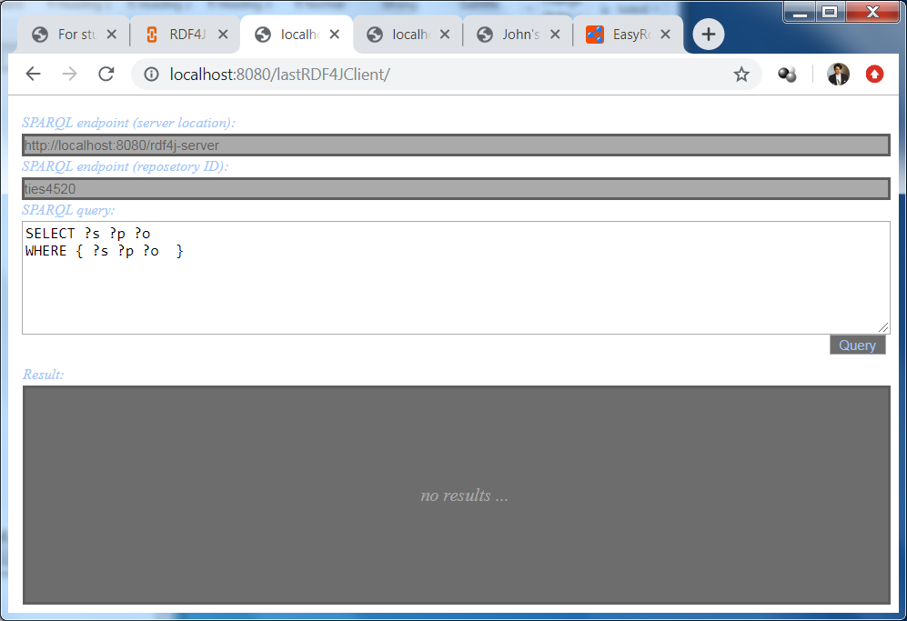

- Save everything as a .war file to be located in Apache Tomcat. Be sure that your .war file contains all necessary libraries (.jar files) required by your service (it should work at any other machine where Apache Tomcat is run).
- Run RDF4J server and workbench in Apache Tomcat, create a repository (with a repository ID “ties4520”) and upload data from RDF file (from Task f3)
- Run your SPARQL endpoint service and try to perform the queries from Task f5 (check the performance).
- Send .war file and project source files (.java, .html, .js, etc. files) as an archive - RDF4J_Endpoint.zip

Task f8: Create a SPARQL and Rule-based Reasoning endpoint service as an endpoint to XHTML file with RDFa content using Jena API:
- Create a servlet to be run in Apache Tomcat server:
  - Create a simple client html page with:
    - a text field to specify URL of XHTML file with RDFa content
    - a text field to specify a Rule(s) (provide an example of rule presentation format that your service supports)
    - a text field for SPARQL query
    - a button to run a query/reasoner (if no rules mentioned, query is performed on top of initial content, otherwise, on top of a content extended with new inferred facts)
    - a field to present a query result (table with values of corresponding variables)
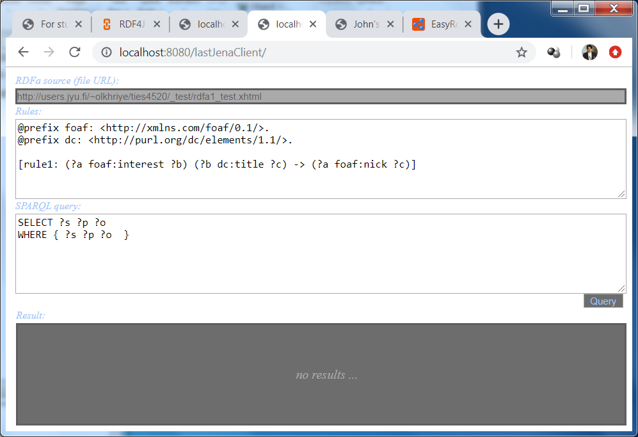

  - Simple functionality of the servlet backend includes:
    - receiving URL of XHTML file, SPARQL query and Rules from the client
    - parsing of RDFa content
    - applying Rules and performing SPARQL query. Be sure that you support different SPARQL query types (select, construct, describe and ask)
    - sending query result back to the client
- Save everything as a .war file to be located in Apache Tomcat. Be sure that your .war file contains all necessary libraries (.jar files) required by your service (it should work as any other machine where Apache Tomcat is run).
- Run your SPARQL and Rule-based Reasoning endpoint service and try to perform the rules/queries from Task f4 as well as queries from Task f5 (check the performance).
- Send .war file and project source files (.java, .html, .js, etc. files) as an archive - JenaQR-RDFaEndpoint.zip

Provide the result of the Final Assignment as an archive of the following files:
- Final.doc (this file)
- RDF4J_Endpoint.zip
- JenaQR-RDFaEndpoint.zip

Send the Semi-Final Assignment result as an archive TIES4520-SemiFinal.zip to lecturer (oleksiy . khriyenko @ jyu . fi)
Documentation
Deadline: 03.11.2024 (end of the day)
Results will be present during the Demo-4 and Demo-5
Documentation

Domain of your ontology: <write here>
URL of the ontology: <write here>
URL of the individuals file: <write here>
URL of the HTML file: <write here>
URL of the XHTML file with RDFa content: <write here>

Your rules from Task f4:
Rule 1: <written in human-readable from>
Rule in N3 logic
-- paste here –
Result of CWM
-- paste the result of CWM here –
SPARQL query to check the results of rule-based reasoning
-- paste here –

Rule 2: <written in human-readable from>
Rule in N3 logic
-- paste here –
Result of CWM
-- paste the result of CWM here –
SPARQL query to check the results of rule-based reasoning
-- paste here –

Rule 3: <written in human-readable from>
Rule in N3 logic
-- paste here –
Result of CWM
-- paste the result of CWM here –
SPARQL query to check the results of rule-based reasoning
-- paste here –

Rule 4: <written in human-readable from>
Rule in N3 logic
-- paste here –
Result of CWM
-- paste the result of CWM here –
SPARQL query to check the results of rule-based reasoning
-- paste here –

Rule 5: <written in human-readable from>
Rule in N3 logic
-- paste here –
Result of CWM
-- paste the result of CWM here –
SPARQL query to check the results of rule-based reasoning
-- paste here –
Your queries from Task f5:
Query 1: <written in human-readable from>
SPARQL query
-- paste here –
Result of RDF4J workbench
-- paste the result here –

Query 2: <written in human-readable from>
SPARQL query
-- paste here –
Result of RDF4J workbench
-- paste the result here –

Query 3: <written in human-readable from>
SPARQL query
-- paste here –
Result of RDF4J workbench
-- paste the result here –

Query 4: <written in human-readable from>
SPARQL query
-- paste here –
Result of RDF4J workbench
-- paste the result here –

Query 5: <written in human-readable from>
SPARQL query
-- paste here –
Result of RDF4J workbench
-- paste the result here –

