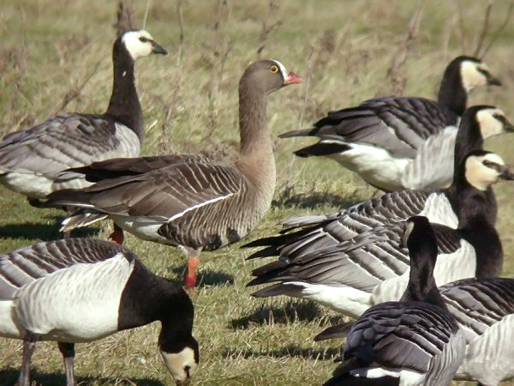

LWfG Bulletin

2015 - No. 2

November 2015
- Best Wishes to the “WWF Team”. Lauri Kahanpää 3
- Fair play journalism? Antti Haapanen and Lauri Kahanpää 4
- The Lesser White-fronted Goose; ex situ or exit. Martti Soikkeli 5
- A follow up. Antti Haapanen 8
- Defending the LWfG in Court again. Antti Haapanen 9
- The Years of United Efforts 1984-1998. Lauri Kahanpää 13
- The General Meeting 2015. The Board 16
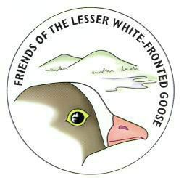

This issue is essentially an English version of the Finnish issue 2/2014.

Publisher Friends of the Lesser White-fronted Goose

KiljuhanhenYstävät ry. - Fjällgåsens Vänner rf. -
- Mail c/o Kahanpää / Sepeteuksentie 19 B / FIN 00760 Helsinki / Finland
- lauri.v.kahanpaa@jyu.fi
- http://www.ansererythropus.tk/
- Chair PhD. Antti Haapanen 358-9-3253804, 358-40-5953313 / Huhtasuontie 7, 00950 Helsinki / antti.haapanen@kolumbus.fi
- Secr. PhD. Lauri Kahanpää 358-50-4652301
- fax: 538-14-2602701 "Lauri Kahanpää"
- Fee 50 EUR
- BIC: SBANFIHH. IBAN: FI49 3939 0032 8487 80
- Goose Breeder Pentti Alho: phone/fax 538-03 7654 727, mobile 538-440-654727.

LWfG Bulletin is the English version of the Finnish language Kiljuhanhen Ystävä. Eectronic versiosn of both are available public domain at http://www.Ansererythropus.tk . Paper printed versions are distributed to members. Both new and older issues are still available free on request.

Best Wishes to the “WWF Team”
Lauri Kahanpää
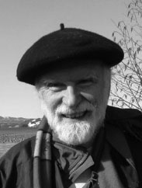

I drove to Liminka. I had started before sunrise. According to Michelin’s route planner it takes 7 ½ hours to get there from Helsinki. The seminar to commemorate 30 years of the Lesser White–fronted Goose Protection Project in Finland would begin at 2 PM. It was November 1 2014. My baggage consisted of a present to the organizers.
There was reason to celebrate. The Project, founded on February 18 1984 had as a first priority initiated ex situ protection of the species in Finland.
The talks at the will be commented on in the story below. But the opening talk was bizarre. Jari Luukkonen, Conservation Director of WWF Finland, claimed that Finland's environmental administration had not been ready to take responsibility for the protection of the species. In fact the administration was part of the Working Group from the very beginning, planning actions and paying for the breeding. Mr Luukkonen emphasized the current good spirit of the working group, its fine international relations and capability to make unanimous decisions. In reality the group stands in open conflict to the programs in Sweden and Germany and their internal cohesion is due to not sending meeting invitations to members with potentially different opinions. Finally, he eloquently foretold the Lesser White-fronted Goose in Finland a rapid population increase and a bright future. The seminar talks themselves speak a different language, just read them at http://piskulka.net/literature/Ansery1533.pdf. The late long term chairman’s of the Project, Dr Ilkka Koivistos memory was honoured without mentioning that he, unlike Luukkonen, accepted facts in both public and in court and strongly advocated Antti Haapanen’s and the Friends’ efforts to reintroduce the species to the Finnish fauna by active means.
Like the group currently operating under WWF Finland’s flag, also the Friends of the LWfG carry the heritage of the original project. There was reason to celebrate! I had had the intention to award the WWF group for their work in field observation and habitat protection efforts. On my way home, my baggage still consisted of the present.

Fair play journalism?
Antti Haapanen and Lauri Kahanpää
On November 3 2014 the Friends of the LWfG sent (in Finnish) the following information to the Finnish news agency STT.

Today November 3 2014, Finnish newspapers have published a notification by the WWF Lesser White-fronted Goose working group on the current Finnish status of the Lesser White-fronted Goose. According to the notification, increasing numbers of these endangered birds were observed on Finnish staging sites. The notification gives a biased view on the actual status of the species. No breeding of LWfG was observed in Finland since 1995; only migrating Norwegian birds are observed annually in spring near Oulu. The local government of Northern Ostrobotnia has recently successfully improved LWfG habitats on coastal meadows of the Bay of Bothnia to attract more of the migrating birds. The migrating Norwegian Geese now stop here for some days but they have not increased in number. Detailed information on Norwegian LWfG can be found on piskulka.net . This autumn only 33 were observed, 22 adults and 11 juvenils in six broods.

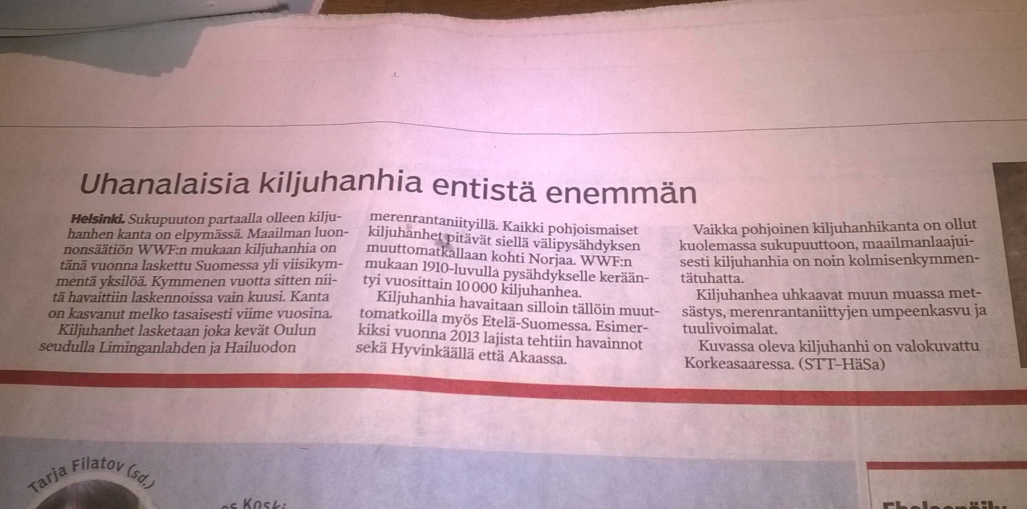

No newspaper seems to have complemented the misleading information although it was easy to check the facts at the URL address of the WWF group itself, piskulka.net !

The Lesser White-fronted Goose; Ex situ or Exit.
Martti Soikkeli
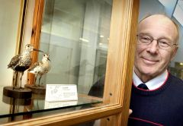
This article was first published in the daily Turun Sanomat (TS) on Feb. 16 2011. The author is professor emeritus in zoology and a renowned specialist in game biology.

The lesser white-fronted goose is extinct in Finnish Lapland and is on the verge of extinction in Norway. Only 10-15 breeding pairs remain there. (Cf. TS Feb 7 2011.) In 1973 I was the first to pay attention to their decrease in Fennoscandia. In 1966−67 they collapsed.

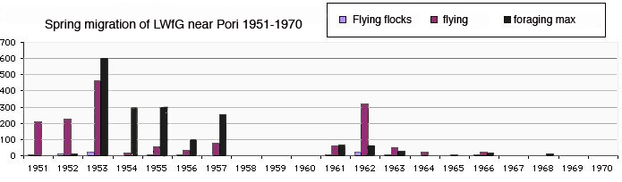
Fig 1: This was the alarm. The writer’s observations of spring staging lwfg near Pori, Finland, published in 1973, showed a decrease from 600 to zero.

Any population is decreasing when its mortality exceeds its reproduction. The decrease of the lwfg has many causes but the main one is their southeastern migration direction via Russia to the wintering grounds. Along that route hunting is uncontrolled and one cannot expect that a flying lwfg would be identified and spared.
In the 1980:s Lambart von Essen invented a method to save the lesser white-fronted goose from extinction in Sweden. Lwfg eggs were given to barnacle geese to incubate in captivity. In autumn the mixed families were released in the breeding area in Swedish Lapland. From there the barnacle goose parents guided the young lwfg to safe wintering in the southwest. In spring the barnacle geese returned to their original nests in southern Sweden whereas the lwfg continued to the fjells and started to breed. As a result Sweden now has the only viable lwfg population in the territory of the European Union.

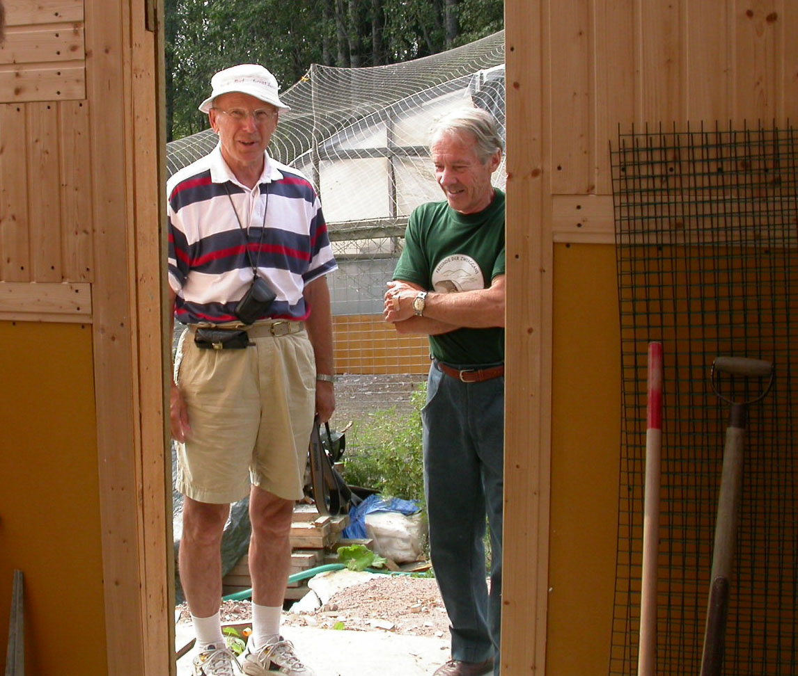

Fig 2. The author visited the Hämeenkoski farm in August 2002.

Soon WWF Finland in a sense followed suite by releasing 150 lesser white-fronted geese in Finnish Lapland. But these geese were too young and were released without barnacle goose step parents. The attempt failed, and WWF gave up. Today the NGO ”Friends of the Lesser White-fronted Goose” continues ex situ breeding of the lwfg and intends to continue releases with proper methods.
The species purity of the captive geese was questioned when geneticists found signs of interbreeding with greater white-fronted goose and greylag goose. Luckily German scientists soon found out that the signs had been wrongly interpreted. The greater white-fronted goose genes turned out to be due to the common origin of these closely related species. The interbreeding with greylag geese seemed real but only very few birds were affected at all and they could be safely removed.
BirdLife Finland, WWF and the Finnish Environment protection authorities have not refuted the German findings but anyway they counteract the NGO’s reintroduction plans as much as they can. One way to do so is to denounce the Friends of the LWfG as quarrelsome people who are not worth paying attention to. In reality the NGO represents the best international expertise and strives for constructive cooperation. The antagonists reject the Finnish ex situ lwfg population without even having examined them. They do not offer “better birds “ either.
Another way to block releases of the Swedish type is to appeal to rules prohibiting the spreading of invasive alien species. By definition, an alien species is not part of some area’s fauna but is taken to there by humans. The administration interpreted the Finnish captive lwfg as an alien species but lost the case in court. The administration did not appeal to a higher court. Instead, a new pretext was invented: Now the barnacle geese supposedly are an alien species. The NGO was sued again. But barnacle geese have always migrated through Finland. Half a century ago the species expanded to breed in the Baltic Sea area and is currently counting thousands of pairs and still expanding naturally in the area including Finland.
Some opponents do not criticize the birds themselves but the plans to teach them to migrate to the southwest. According to them this should be prohibited even though the species has a history of southwest migration and the southeast migrating individuals are being shot to extinction. The Swedish geese fly to the Netherlands where they survive on specially protected areas.
Hopefulness is allowed but one should also be realistic. Today our administration contends itself with watching how the southeast migrating Norwegian lwfg die out. It is peculiar that they concentrate on Norwegian birds, not on reviving our own.
Unless new birds are released and guided to safe southwestern migration routes the lesser white-fronted goose will not return to Lapland.

A follow up.

Antti Haapanen

On June 8 2011, four months after the publication of professor Soikkeli´s article above, three members of the NGO Friends of the Lesser White-fronted Goose were condemned at a regional court in Lapland for having released an invasive foreign species in Lapland. One was fined, two warned. The court considered it proven that both the released Lesser White-fronted Geese and the Barnacle Geese represented an alien species. This decision was later maintained at a court of appeal. The NGO appealed to the Supreme Court but after a delay until March 2014 the Supreme Court decided not to take up the case. Therefore no binding prejudicate exists today on whether these geese are alien species in Finland or not. But there exist two contradicting decisions in lower courts. The first one allowing the reintroduction measures was given on September 7 2005 and the other one, prohibiting the same action, is the one mentioned above.

Nisäkkäät ja linnut

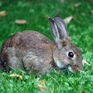 | - amerikanmajava (Castor canadensis)  - kanadanhanhi (Branta canadensis)  - minkki (Mustela vison)  - supikoira (Nyctereutes procyonoides)  - kuparisorsa (Oxyura jamaicensis)  - kaniini (Oryctolagus cuniculus)  - rotta (Rattus norvegicus)  - kissa (Felis silvestris catus)

The Finnish Museum of Natural History has an official list of alien species. The URL is vieraslajit.fi . The list of alien mammals and birds mentions only one goose species the Canada Goose. The only other bird on the list is the Ruddy Duck.

Defending the LWfG in Court again.
Antti Haapanen
Part one: releases of “alien species”
The ”follow up” to Martti Soikkeli’s article gives a glimpse on how some Finnish environmental authorities look at the NGO ”Friends of the Lesser White-fronted Goose” and our attempts to reintroduce the LWfG in our country. All possible and impossible ways are used to block our efforts and annul our achievements. Recently they have even contradicted their own statements – in court.
Senior Adviser Matti Osara represented the Ministry of the Environment in the alien species working group installed by the Ministry of Agriculture and Forestry. The working group had to set up an action plan against the threats and risks caused by non-native species. The working group wrote such a document and it was signed by all including Mr Osara. The document begins with a definition of the concept ”alien species”.
Alien species are species, which have expanded from their natural range to a new range with humans either accidentally or intentionally. An alien species has by human contribution overcome natural barriers like a continent, sea or mountain range
This is ecologically correct. What is not correct is that Mr Osara a couple of months later as a sworn witness in court testified that there are “locally alien species” in Finland – even birds. In particular, the Barnacle Goose in Finnish Lapland. He suddenly seemed to be unaware of the definition of the concept ”range” in the Convention on the Conservation of Migratory Species of Wild Animal Species (Bonn convention). The range covers migration routes and wintering areas.
Another witness in the same trial was professor Jaakko Lumme, who was to prove that the released LWfG represented an alien species. That was not easy. His department at Oulu University – or any Finnish geneticist for – had never studied the birds in question. In spite of this he was absolutely sure that the birds were an alien species. We mentioned to the court that our original geese were from the Swedish Hunters Union’s captive population and that those birds were tested to be at least 97 per cent identical to free living original Swedish LWfG. I asked Mr Lumme the question: Do there exist ”clean species” in Nature at all. His answer was ”No!” That was true. It seems, the court did not catch the importance of this conversation.
As the reader may know, we lost the case: Pentti Alho, my son Matti and I were found guilty for spreading alien species and I was even fined. We had released a mixed family of Barnacle Goose as step parents with LWfG young in Lapland. We complained but the court of appeal did not change the verdict. Later the Supreme Court did not take the case up. So we have made an official complaint to the EU Commission accusing the Finnish officials for giving false information in court. How stupid! Instead of spending energy on suing conservationist NGOs to unnecessary trials the Ministry should let us cooperate to save the Geese!
One may also keep in mind that our birds never have shown visual signs of hybridization with Greater White-fronted Goose.
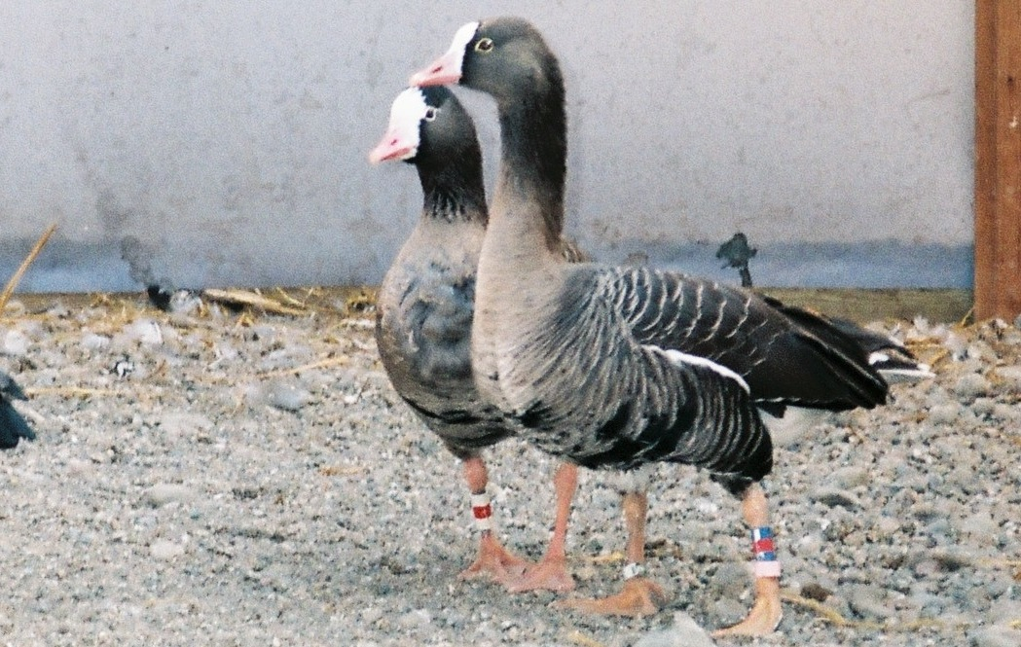
Fig 1. A typical pair of LWfG at Hämeenkoski.
A picture like fig 1 above, showing the clean exterior of the LWfG in Hämeenkoski, is attached to our complaint. Also we have at every instant welcomed an independent inspection of the birds.
In biological systematics there are many definitions of the concept ”species”. Wikipedia :-) lists at least eleven different definitions like “sets of organisms potentially interbreeding, exploiting a single ecological niche or with gene exchange limited by a reproductive mechanism”. In 1993 Ridley even defines a species as a “set of organisms that look similar to each other and distinct from other sets”. New traits to the species question come from DNA-studies, often clarifying matters and showing the common origin of similar looking organisms. It is also common to find traces of natural hybridization in individuals of adjacent species. I am an example of this myself: European Homo sapiens carry some 4-5 % genes from interbreeding with the Neanderthal man likely between 50,000 to 60,000 years ago.
The Swedish reintroduction method needs ”step parents” for the young LWfG. Except for the first one all our applications for permits to catch some of these protected(!) birds were rejected by local government officials in the Turku and Helsinki area. The appropriate courts later confirmed the decisions falsely interpreting the Barnacle Goose as an alien species. A protected alien species?

The “alien species” misinterpretation is not our only reason to complain at EU level. According to the Charter of Fundamental Rights of the European Union 2000 nobody can be tried again for a crime for which he has already been found guilty or not guilty in a legal court. In a similar trial some years earlier at the same court our previous, completely identical, release had been declared legal. (Fig 2) The Commission of the EU has promised an answer to our complaint in 2015.
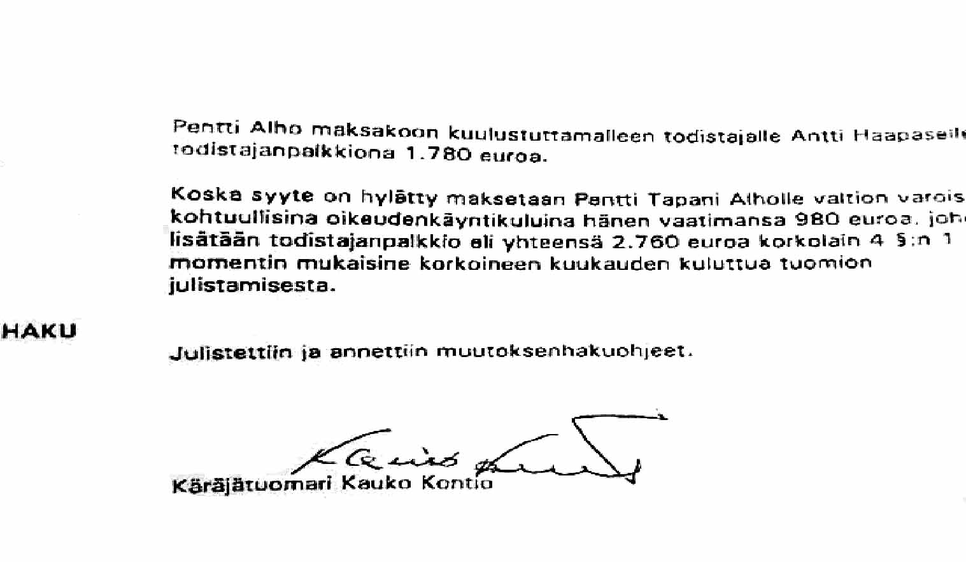
FIg 2. The identical release in 2004 was judged legal.

Part two: import of “pure LWfG”
The minimum number of individuals in a viable captive population of any species is generally agreed to be about 300. Therefore zoos interchange animals. Also the Finnish ex situ LWfG population needs some fresh blood now and then. Already in the 1990s we applied for a licence to import some LWfG from Russia. It was not granted
More recently, we were offered the opportunity to import some Geese or eggs from Germany. We applied for an import licence. The birds were of East German origin, their parents from Russia. Their genetics was checked at Heidelberg University under supervision of professor Wink.

Again our Ministry of the Environment draw the brake by not recommending the import. A similar statement came from the Finnish Environmental Institute (SYKE). So our application was rejected at the first instance and after years of waiting and appealing it finally found its way through the massive bureaucracy to the Supreme Administrative Court. And at last someone reacted! On May 16 2014 the Supreme Administrative Court cancelled all previous decisions on the matter and sent it back to the first instance, the Finnish Wildlife Agency, for better evaluation. In order to escape loosing their face the Agency came up with an inventive solution. They suddenly noticed that the Agency is only responsible of matters concerning hunted species and the LWfG is not hunted. According to the Agency’s interpretation of paragraph 45 of the Nature Conservation Act the “Centre for Economic Development, Transport and the Environment” in Hämeenlinna is the authority which will grant such licences.

We have informed the Centre on the ”purity” of the import birds. The former arguments cannot be reused to block the licence. The case is still open. Undoubtedly it will be affected by the EU decision in the other case described above in part one.

The Years of United Efforts 1984-1998.
Lauri Kahanpää
It was in July 1998 that I joined the Lesser white-fronted Goose project. The original working group had collapsed and the new NGO was founded to continue efforts to reintroduce the species in Finland. Fifteen years later, at the seminar to commemorate 30 years of the Lesser White–fronted Goose Protection Project in Finland I listened to talks by the invited pioneers who reported on the first years and later developments from their respective viewpoints. The talks are published in the net at http://piskulka.net/literature/Ansery1533.pdf Some are in English some in Finnish. They were helpful in writing the following short history.

The original LWfG working group was founded in Helsinki on February 18 1984. There was a strong motive. Already in the 1970s Martti Soikkeli had published alarming information on the end of the LWfG spring migration near Pori and the remaining staging grounds near Oulu were under continuous monitoring. Surveys had been made in connection with work for the first Finnish Atlas of Breeding Birds. Art the same time Norderhaug & Norderhaug had collected material for their well-known paper. (Finnish contribution by Pentti Vikberg.) Obviously something had to be done. Eino Merilä, Pekka Nieminen (Goose breeder in Hailuoto near Oulu!), Matti Tynjälä and Juha Markkola wrote a letter to Lambart von Essen in Sweden. They proposed to join forces in breeding and releasing Lesser White-fronted Geese in Sweden and Finland. Von Essen contacted the Finnish Hunter’s Central Organization (Metsästäjäin keskusjärjestö) and WWF Sweden contacted WWF Finland. Here the Ministry of Agriculture and Forestry (Pertti Seiskari) promised some moderate financial support. Invited by WWF Finland, the following persons were present at the founding meeting of the Finnish working group
- Pertti Kalinainen (researcher, journalist, Pori)
- Pentti Alho (breeder, Hämeenkoski)
- Pentti Vikberg (Finnish Hunter’s Central Organization)
- Juha Markkola (secretary),
- Pekka Nieminen (breeder, Hailuotoi)
- Matti Pirkola (Natural Resources Institute Finland RKTL)
- MattiTynjälä (Oulu)
- Elja Herva (Oulu)
- Pertti Rassi (Ministry of the Environment)
- Ilkka Koivisto (chairman) (Helsinki Zoo) and
- Markku Vickholm (Oulu, today living in Vantaa)
Soon afterwards the following joined the group
- Eino Merilä,
- Esko Jaakkola (Ministry of the Environment),
- Antti Karlin,
- Lassi Karivalo (WWF).
Disagreements arose already at the second meeting of the working group, who made a fundamental mistake, which later brought down the whole project: The Ministry of the Environment did not accept the use of step parent Barnacle Geese. This was not clear to all in the beginning. One line of action were Intensified field observations. As a result we now know almost all about the whereabouts of spring LWfG on the West coast. More then that, in summer 1989 Heikki Holmström and Juha Merilä found a breeding cluster in Lapland with at least 23 individuals and 8 broods. In the following two years there were even more, up to 15 breeding pairs in 1991. But then disaster stroke. Bad weather prevented all breeding in 1993 and since 1996 the site is permanently abandoned. At the seminar Martti Rikkonen showed wonderful photographs of the last breeding in 1995.
The character of the LWfG working group changed when young field ornithologists joined it. They were exited of having seen the breeding birds. Risto Karvonen, Ari Lavinto, Petteri Polojärvi, Jyrki Pynnönen and Petteri Tolvanen joined Heikki Holmström. This explains the group’s peculiar shift of focus to observation instead of active protection/restocking. When no LWfG breedings were found in Finland any more, observation activity was shifted to foreign countries where there still was something to see. Birds migrating through Finland were re-defined as “original free-living Finnish LWfG”. Excellent fieldwork was done: it became possible to identify individuals by their black belly patches. To their own embarrassment the working group proved that they had found the only breeding area of all LWfG migrating along our coast to Norway in spring. None of them continues to Russia. No other breeding area exists any more.
As a side work, the working group half-heartedly continued breeding and releasing. The readers of this Bulletin know that things went wrong and the working group split, when some wanted to give up reintroduction altogether and others wanted to improve methods imitating the Swedish project. The minutes of the stormy final meeting in 1998 are sad reading. It is worthwhile to recall the previous history of the first breeding project decade that led to the catastrophic schism.
At the 30 years seminar in Liminka goose breeder Pekka Nieminen from Hailuoto told his story. His breeding station was built up with a small sum of government money in 1985. Pekka Nieminen together with famous Ilkka Koivisto from Helsinki Zoo travelled to Sweden where Lambart von Essen taught them the art of LWfG breeding. Today, 30 years later, the Swedish have definitively succeeded in large scale LWfG breeding with an output of more than 50 young birds annually. In comparison to that, it is interesting to recall how difficult it has all the time been in Finland – and why. Pekka Nieminen’s talk gave me an opportunity to upgrade my previous knowledge of the impact of import, releases and unexpected problems on the population growth in Hailuoto. I hope the next diagram depicts correct numbers:

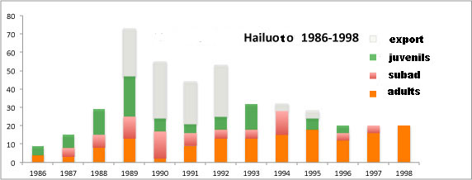

In the beginning population growth was fast. Soon releases surpassed the production capacity of the breeding and in 1990 the export of more than 20 adult birds to the new breeding site in Hämeenkoski gave a final blow to the first ex situ population in Hailuoto. Even without more excess stress, breeding in Hailuoto stagnated. An unexpected problem was bird tuberculosis, diagnostised in 1992. But that was not the decisive factor. The farm was successfully disinfected. The soil was cleaned and eggs hatched in incubator. This was successful. Mortality of eggs and juveniles sunk even below the original (In 1992 62%, later about 30 %). Adult birds were killed among others by a goshawk, gout, blood loss and mycobacteriosis. During the years the 16 original birds gave rise to 143 releases and 22 exports to Hämeenkoski, net 165. When cooperation with the working group ended in 1998, 20 LWfG remained in Hailuoto.
Also the second breeding site, Pentti Alho’s farm in Hämeenkoski, was founded during the years of a solid working group. The government incarnated as the “Centre for Economic Development, Transport and the Environment” in Hämeenlinna financially supported it. (Mentioned in the previous article). The first 20 birds came from Hailuoto. Before 1998 up to 50 more LWfG arrived directly from Sweden, some from Germany. During the common project years 5 adults and 43 juveniles were released from, even these numbers higher than what would have been possible in the long run.
The General Meeting 2015
The Friends of the Lesser White-fronted Goose held our annual meeting in Valkeakoski, Finland, on April 9. 2015. In addition to the necessary administrative matters we spent time on thinking over how the Lesser White-fronted Goose could be saves and become an enriching part of Lapland’s Nature again. What else!
Formal things first: The meeting was found correctly invited and competent. The annual report and financial report (deficit 1000 €) of 2014 were confirmed. The member fees 200€ for institutional members, for persons, 50 € or 8 hour’s work, was not changed. The board presented the action plan and finance plan for 2015 and the general meeting accepted them without change. The board was re-elected:
- Antti Haapanen (chairman, Helsinki)
- Erkki Jaanu (Valkeakoski )
- Lauri Kahanpää (Helsinki)
- Erkki Kellomäki (Hämeenlinna)
- Eero Peltonen (Tampere)
Deputy members: Jyrki Patomäki, Pekka Ruokonen and Jouni Riihimäki. Auditor Kirsti Krogerus, deputy auditor Lasse Liukko. The newly elected board nominated Erkki Jaanu vice chairman, Lauri Kahanpää secretary and Ari Lehtonen treasurer.

Actions in 2014
Because of the delayed 2014 general meeting many 2014 actions were already described in the previous Bulletin. The most expensive action in 2014 was the major overhaul of the series A breeding section.
By the end of the year 2014 there also was some progress in the prolonged legal processes. The Supreme Administrative Court nullified the decisions in lower instances, which had rejected our application for an import license. Our application will be re-examined at the local “Centre for Economic Development, Transport and the Environment” in Hämeenlinna. Curiously, it is the same institution, which financed the breeding station 20 years ago and in 2008 obliged us to go on breeding in exchange for donating to us some of the buildings, among others the A-compartments. Now the Centre probably stands under pressure from the Ministry.
The unclear juridical situation with two contradicting legal decisions still hampered releases in 2014. The affected members Alho and Haapanen sent a complaint to the Commission of the EU.
In December 2014 we began to update our proposition for a national Action Plan named “The Plan to Restore the Favourable Conservation Status of the Lesser White-fronted Goose in Finland”. The original plan was published in Finnish in 2008, and a slightly revised English translation in 2008. (Today, the Finnish government has no legally binding action plan for the LWfG. There exists an internal administrative document, composed by BirdLife Finland, but the Chancellor of Justice has noted that is is only a recommendation which cannot be referred to in court since it is not correctly formally accepted; the Ministry never consulted with the potentially affected people.) By the time of writing this, our own updated plan already exists in electronic form in English. It takes into account six years of new observations. Some highlights:
- Still the last confirmed breeding of free living Lesser White-fronted Goose in Finland is from 1995. There is an increase in spring migration observations. Norwegian birds have found the improved habitats on the Finnish west coast.
- There is more detailed information on the Norwegian LWfG than ever. But their autumn migration over Russia is still largely unknown. Counts in winter in Greece and Turkey and along the spring migration route via Hungary and east of the Baltic Sea to the accumulation area in Norway have shown that the threats during migration prevail. The unexpected increase of the Norwegian LWfG population in 2011 and 2012 was due to an exceptional number of Lemmings. In Lemming years, predators have plenty of food even without attacking goose nets and juveniles. The geese use the opportunity to multiply fast. Even though most of the juveniles died on their first migration, the Norwegian population was doubled to about 60 individuals in 2013. But Lemming years have their price. Also the small predators multiplied in the good years. When the Lemmings are gone, they are many and hungry and now the geese have a worse time than before. In autumn 2014 the Norwegian population was back on its track of negative growth. (Read more in the Goose Bulletin 16.)
- Updated exact information on on the Swedish project was still missing by the end of 2014. Anyway, the new stock at Nordens Ark is viable and produces so many young that the Swedish have been able to continue to release birds in Swedish Lapland. This time it was experimentally done without stepparents but inside the dense breeding area and possibly together with natural parents. The results seem to vary. On the other hand, the free birds in Swedish Lapland have multiplied in the Lemming years and suffered losses thereafter.
- From Russia there was bad and good news in 2014. It is becoming clear that there are no significant numbers of LWfG breeding near Finland, that is on the Kola Peninsula. The same seems to be true East of the White Sea. Russian researchers were even delighted when they discovered a few breedings there. The general understanding is that some 500 LWfG breed in and immediately west of the Polar Urals. (The about 60 parent birds for the new Swedish ex situ population were collected there.) There is no fresh data available from the Polar Urals and almost no information at all of what goes on farther in the East. We have heard of new hunting restrictions in the steppes of Kalmukia. In the Far East the LWfG seems to be rather stable at the moment but the future of the central, if not only, wintering area, lake Dongting Hu. is open. This one lake, albeit a big one, is pivotal for the future of the Eastern half of the global LWfG population.
- Our analysis of protection needs and recommendations could unfortunately be left almost unchanged. In the light of fresh numbers it is only more evident than ever, that the LWfG will not return to Finland in the next 50 years unless it is reintroduced by releases of captive birds.

Actions for 2015
The fundamental goal of the NGO Is the reintroducing a viable LWfG population in Finland. In practice this includes keeping the birds and the breeding site in good shape. In 2015 international cooperation is needed for importing new birds to the farm in order to enhance health and production capacity of the geese. There is hope for both an import license and for birds. In particular it is encouraging that the new Swedish ex situ population is doing so well. If the Commission of the European Union makes the right decision with respect to our complaint, the door is open for further releases with the Barnacle Goose method. If not, then we must rely on our sister organization Aktion Zwerggans’s more expensive system with ultra light airplanes as stepparents. No Ministry can claim that airplanes are no alien species.
In 2015 we also intend to restart our project to develop better and cheaper devices for electronic tagging of migrating geese. Our tagging of LWfG was originally a project in cooperation with Jyväskylä University. Three times we tagged Barnacle Goose (step) parent birds using the ARGOS satellite system and SPOT2 and SPOT3 platforms from the company Wildlife Computers. They cost about 1000 € apiece. We had the idea to replace the expensive system by simply fitting the birds with normal cellular telephones, which can be spotted by the telephone net operators. Of course, the phones had to be stripped of all surplus mass, made water tight and be programmed to take contact only about once a day – or week – to save energy. A suitable battery had to be found. The idea was good but we presented it in a time when Finnish electronics engineers were making more money in the boom company Nokia.
Today times have changed and we may again try to find a suitable partner. Also the Goose Specialist Group of Wetlands International has called for progress in the area.

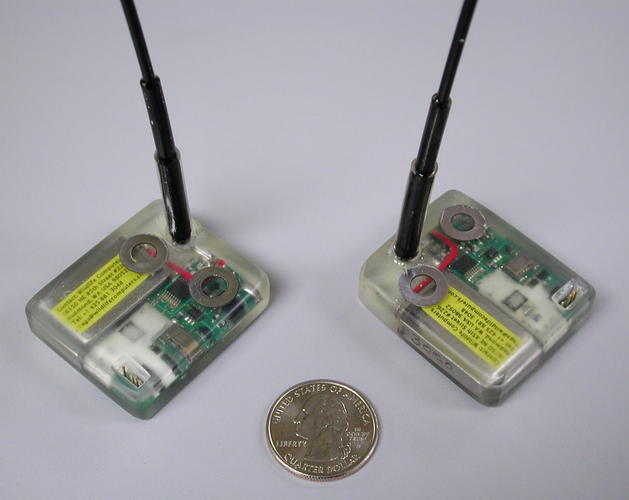

Valuable goods. The transmitters
Wildlife Computers SPOT2 (above) and SPOT3 (size and shape of a fountain pen) cost more than 500 € without tax. (Our partner, Jyväskylä University did not have to pay.) Add the costs for the ARGOS satellite service. Admittedly the tags worked well.

ISSN-L 1798-0437
ISSN 1798-0437

