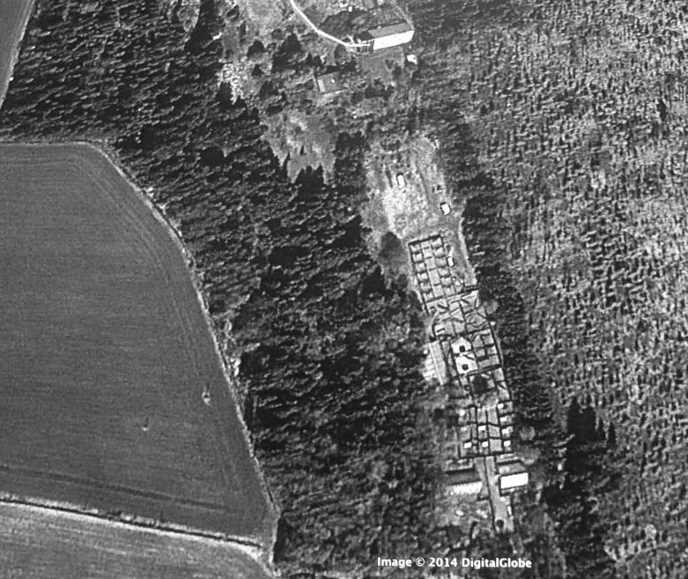

LWfG Bulletin

2015 - No. 1

October 2015
- Editor's Note: Lauri Kahanpää 3
- Carpentry for Geese Pentti Alho and Lauri Kahanpää 4
- Friends of the LWfG - Report 2012-2014 16
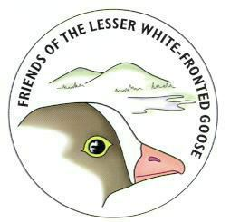

This issue is essentially an English version of the Finnish issue 1/2014.

Publisher Friends of the Lesser White-fronted Goose

KiljuhanhenYstävät ry. - Fjällgåsens Vänner rf. -
- Mail c/o Kahanpää / Sepeteuksentie 19 B / FIN 00760 Helsinki / Finland
- lauri.v.kahanpaa@jyu.fi
- http://www.ansererythropus.tk/
- Chair PhD. Antti Haapanen 358-9-3253804, 358-40-5953313 / Huhtasuontie 7, 00950 Helsinki / antti.haapanen@kolumbus.fi
- Secr. PhD. Lauri Kahanpää 358-50-4652301
- fax: 538-14-2602701 "Lauri Kahanpää"
- Fee 50 EUR
- BIC: SBANFIHH. IBAN: FI49 3939 0032 8487 80
- Goose Breeder Pentti Alho: phone/fax 538-03 7654 727, mobile 538-440-654727.

LWfG Bulletin is the English version of the Finnish language Kiljuhanhen Ystävä. Eectronic versiosn of both are available public domain at http://www.Ansererythropus.tk . Paper printed versions are distributed to members. Both new and older issues are still available free on request.

Editor's Note
Lauri Kahanpää
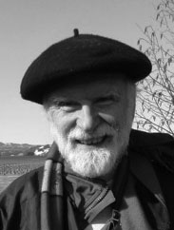

This issue of the Bulletin focuses our practical activities, breeding Lesser White-fronted Geese at Hämeenkoski, Southern Finland. This focus is well motivated – the reintroduction of the species in Finland relies on captive birds. So let us concentrate on active conservation work!

Since our last report, our breeding site has undergone a major overhaul, this time by a professional construction company. Of course, also Pentti Alho and the Friend's volunteers have contributed all the time in keeping the site and the Geese in good shape.

Keep in mind that our government is obliged to restore the favorable conservation status of the Lesser White-fronted Goose in Finland, and this is also documented in national legislation. According to the Finnish Nature Conservation Act (1096/1996 - 5:3 §), the conservation status of a species "shall be taken as favorable when the species proves capable of maintaining itself on a long–term basis as a viable component of its natural habitat." This phrase has never been interpreted officially. Very convenient! As long as one's goal is not expressed in numbers one can not be accused for not reaching or even approaching it. What a contrast to Sweden! In the Swedish reintroduction plan the goal is set at increasing the current twenty breeding pairs tenfold until 2025. Since not all Geese breed, this is equivalent to 300-400 individuals. That could be a model for Finland!

Carpentry for Geese

Pentti Alho and Lauri Kahanpää

In autumn 2014, twelve breeding compartments A1 to A12 - in 1999 originally donated and built by the local government - were totally renewed. This costly operation was a major improvement but not unique in the long construction history of the breeding site in Hämeenkoski.

Last year (2014) the NGO Friends of the Lesser White-fronted Goose could celebrate their fifteenth anniversary. In 1999 there was an immediate need to form an independent organization to take care of the Finnish Lesser White-fronted Geese. The captive Geese had recently been abandoned by WWF, and the free living ones had died out. The breeding farm in Hämeenkoski had just reached the age of ten years. In fact a first attempt to breed LWfG in Finland had been started already in spring 1986 when WWF and the Ministry of the Environment had imported two pairs from Sweden to the island Hailuoto near Oulu at the Gulf of Bothnia. They had proven very fertile producing five young already in the first year and three years later the first three birds were released in Finnish Lapland. To increase production, the second breeding site was built up in Hämeenkoski. This turned out to be a happy decision since the private breeding site in Hailuoto was later struck by bird tuberculosis and closed in spite of a successful disinfection.

Why WWF and the Ministry of the Environment gave up their support for the Finnish reintroduction program in 1998 should be the subject of investigative journalism. We will not discuss it here. Since then they concentrate on observation of migrating and wintering Geese and "natural" reviving attempts like care of habitats in the faint hope of a spontaneous recolonization from Norway.

But in the first years after 1998 some local representatives of the government still prepared for reviving the original program as a plan B. For this, the continued existence of the breeding site and flock was essential since there were few new birds available abroad. Also, it had already become clear that building up a new population was
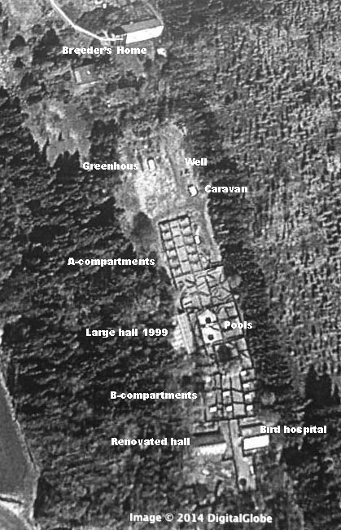

The Goose farm. Most diagonal shadows are obstacle tarpaulins. The storage building lies 400 m off the picture area.
difficult, costly and time-consuming. Therefore, as a last act of governmental support, the breeding site in Hämeenkoski was substantially improved in 1999. Among other new constructions a large winter hall was erected and the closed breeding compartments A1 to A12 were built. All new buildings were government property, leased to the Friends of the LWfG on the condition that we continue breeding LWfG for at least eight more years. That was done. Not only did breeding Geese continue but also the newly founded NGO built a deep well and a piping system for supplying water to the breeding compartments and to a new built swimming pool which was kept free of ice all year round.

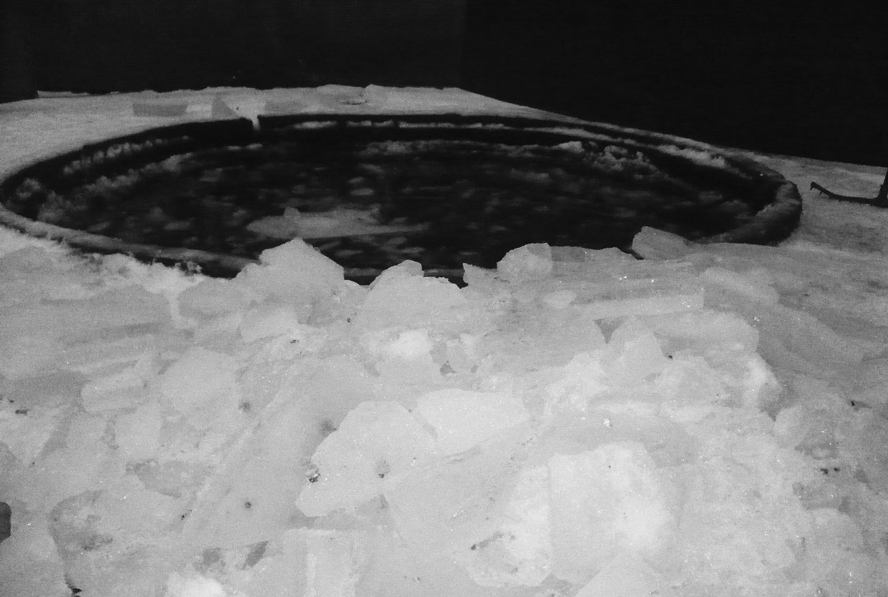

The pool is kept ice-free by the incoming water from the well. At Christmas 2012 the pipe froze and the pool gathered a cover of 10 cm ice. Fortunately, the pipe could be melted and the ice cover dug up by hand.

After the first chock, the finances of the breeding site were balanced for four years by the EU in cooperation with the town Heinola, the Finnish Hunter's Union, local nature conservation organizations and the local government. Our bird hospital was built in this time, but soon after opening the hospital was closed because of the possibly pandemic bird influenza. All avian wildlife was considered a health risk.
After the end of the EU project, Finnish LWfG reintroduction efforts were completely privatized and run by volunteers. The number of Finnish LWfG at Hämeenkoski increased to about 100 individuals. In the mean time the Swedish restocking program had shown considerable success and experimental releases with the Swedish method were started in cooperation with Jyväskylä University. The university provided for biological expertise and participated in the cost for electronic tagging of the released birds.

Even without public funding the volunteers were able to continue to construct buildings and to improve systems at the breeding site. One innovation was the introduction of what we call obstacle tarpaulins. Many Geese were killed breaking their necks when flying against the cage walls. Spanning about 200 m^2 of vertical tarpaulins cut their flying distance to less than 5 m, effectively reducing their speed. This solved most of the problem but keeping the tarpaulins in shape needs a lot of work since they must be cut and sewn to size and renewed biannually. In less then three years they degenerate into glass fiber chords, which can wrap around the legs of the Geese. Like all work in the cages changing tarps needs great care since the birds are shy and the swarm can panic fatally.

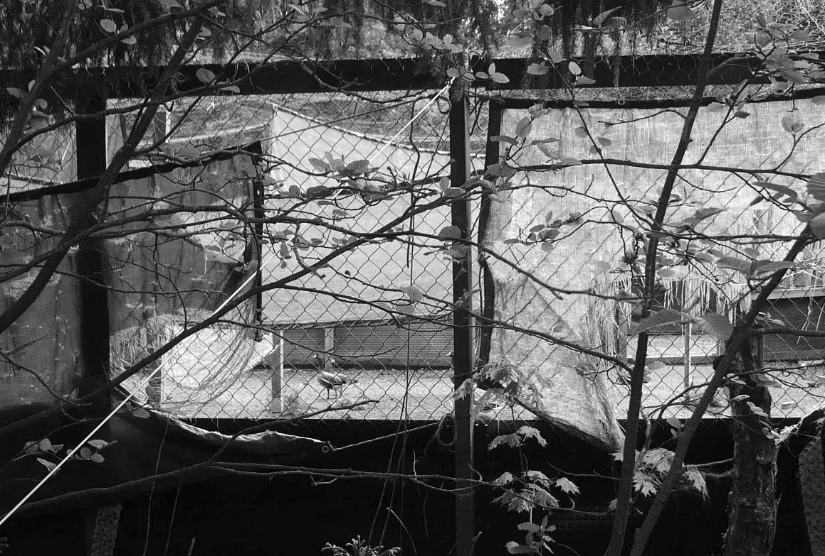

Under stress or in the sun tarpaulins degenerate into dangerous chords.
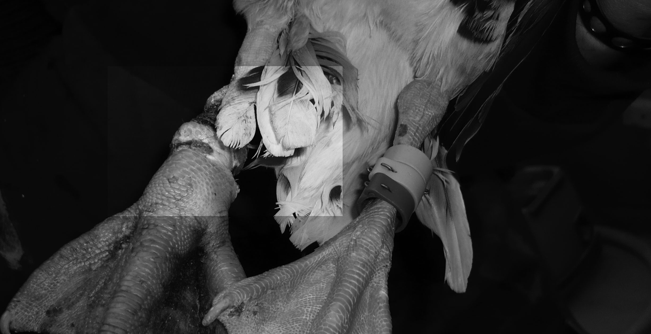

A glass fibre chord around a leg can be fatal.

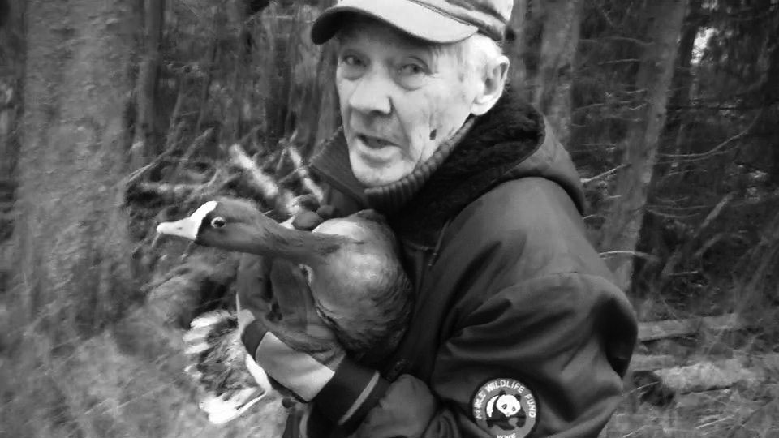

The Goose in the photo above had spent two days hanging from its leg and wing until it was noticed and successfully rescued.

Initially, the buildings in 1999 to 2001 were intended to replace rotten original constructions from the 1980s, two winter halls and ten breeding compartments. Later some structures of one hall were used as material for the bird hospital, but the other hall was rebuilt from scratch as were the breeding compartments B1 to B10. Also, a 36 m^3 rat-proof concrete food storage house was built north of the breeding area which was now completely renovated. For an impression of the work done one can notice that there are 60 doors, 600m of pipes deep in the earth, and more than a km of 2m high metal fence, going 50 cm down into the earth to keep rats away. The area is covered by a 2000 m^2 net, later replaced twice. A Caravan was bought for volunteers staying over night and the purchase of an AVANT 220 mini-tractor made daily work easier.

In the snowy winter 2005-2006 the breeding site was struck by an extreme blizzard. The halls survived but half of the Finnish Lesser White-fronted Geese were lost in a couple of hours when the roof nets collapsed under the weight of 40 cm of wet snow. Giving up was seriously considered but rejected. Fallen fences had to be straightened. The roof nets had to be replaced. Their absence made it possible to bring in heavy machinery to replace the soil with clean sand. To avoid future snow problems, the area was divided into parts by added fences. At first everything seemed hopeless in the winter darkness, but on retrospect we appreciate the warmth and cohesion created by our cooperation under extremely difficult conditions.

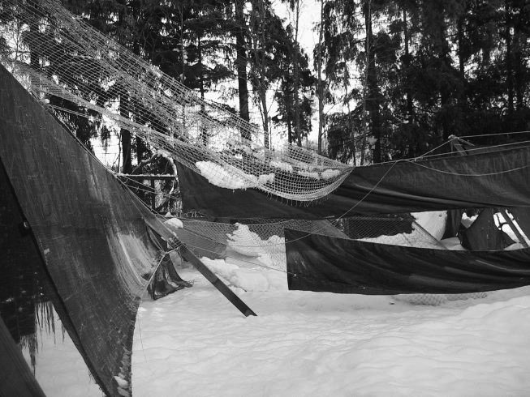

On December 1 2005 half of the Finnish LWfG lost their lives in a blizzard.

In 1999 it was clear that reintroduction of the LWfG in Finland would take a long time. The newly founded NGO prepared for decades of work by building long lasting constructions. Today all the wooden constructions are made of larch wood or impregnated pine, the metal fences are of plastic coated material and former textile nets are largely replaced by metal. Still there is constant need for maintenance work. One problem is the freezing of the earth in winter. Every winter the ice loosens some water pipes from the bathtubs in the breeding boxes and, what is worse, lifts the underground fence constructions up several cm a year. That adds up, and sooner or later the rat fences are destroyed or at least have to be replaced and dug in again.

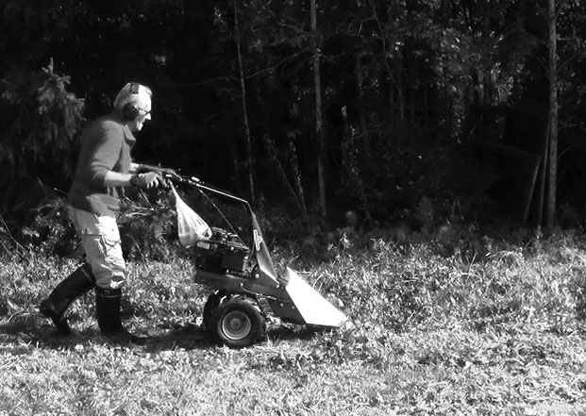

Except in winter, fresh green from outside is daily cut for the Geese.

The most recent large improvement is the 2014 renovation of the twelve A-series breeding compartments, originally built in 1999. There was a prologue to this work. In the summer 2011 a German zoo had donated 14 LWfG to Finland. The birds were ultimately of Russian origin, therefore acceptable by all nature conservation organizations including those who had doubts on Swedish birds. So we thought. In EU legislation all Goose species are defined as poultry, so corresponding veterinary import rules had to be followed. At Hämeenkoski physical preparations were made for receiving the newcomers. Not only was the former bird hospital isolated to become a quarantine area but also a larger part of the breeding farm was reserved for them permanently as long as they would not be allowed to mix with the old flock. A vacant winter hall and a separate pool were available. In the bird hospital there still were 4 other birds to be taken care of. They had to be removed somewhere else. For this purpose one of the series A breeding compartments, number A4, was experimentally sealed with a plastic roof and dense metal net walls.

Before reporting on further work on the compartments let us mention what happened to the Russian-German Geese. Things went wrong. They had all necessary import papers and a van was sent to transport them to Finland. In Germany it turned out that some Finnish officials – we still have not been informed who and why - threatened that the Geese would be confiscated, possibly killed when reaching Finnish soil. There was the risk that the extremely threatened birds would be harmed at the border. On the other hand, we did not want to do anything that could be interpreted as smuggling. So the risk was not taken. Later the case was taken up in court, and the supreme administrative court has recently stated that Finnish officials made mistakes. That is of little comfort. In the mean time the valuable birds were lost. A current process will decide whether the import of any LWfG to Finland is legal and whether it was right to discriminate our NGO. Of course importing LWfG for breeding and release is legal in fact, and the Ministry of the Environment itself should do it.

After the failed import attempt in 2011 the roofed compartment A4 was empty over one winter and was used for breeding in 2012 like the other compartments. In the next winter there were several intensive snowfalls causing some damage to roofs and fences. In particular, the roof of compartment A4 collapsed under the snow load. Repairing and reinforcing it was postponed to the summer and took a week's work.

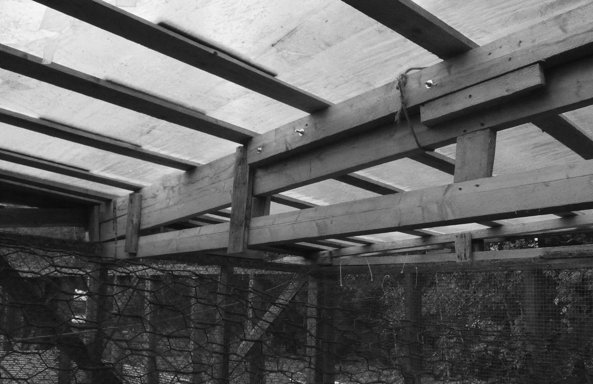

The broken beams were lifted and supported from below.

In the breeding compartment system the Goose pairs can choose in which compartment they want to breed. Every compartment's door is kept open until some pair accepts it. As a result some pairs breed in the A-area north of the pool, some others in B south of the pool. All in all, the fenced and roofed area is more than 100 m long and lies in a former field on a southern hillside. So the A-compartments lie at the upper and the B-compartments and the bird hospital at the lower end. The Google maps image shows that the B-compartments are larger. Since they lie downhill they are also more humid. They can become muddy in wet years or when the piping system floods. Flooding can occur for various reasons; the Geese are very clever in turning taps and clogging sewers. All cages have a 10 cm layer of clean sand but that does not always stop the clay beneath from mixing with the sand and excrements of the Geese into unbelievable dirt. That cannot be helped during brooding or when the goslings are small. Surprisingly wet conditions do not affect breeding results negatively but the upper compartments are nicer to take care of. In some years there is something else that is much worse for the goslings than water. Rats. For a gosling a rat is a dangerous predator.

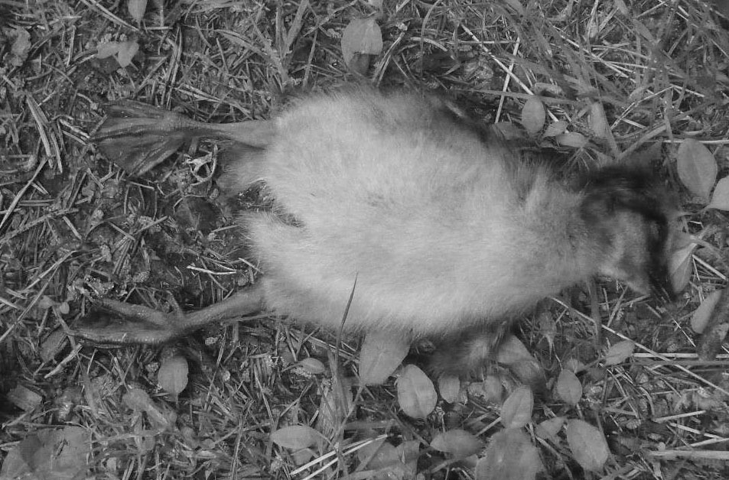

Rat nets extending deep in the soil are indispensable for the safety of the goslings.

In open terrain an LWfG will probably generally be able to defend a gosling against a rat attack, but if the gosling comes too close to a rat hole, the rat may bite it quickly and return to the hole. To avoid this the fences of the breeding compartments were intended to be somewhat rat-proof. The lowest one-meter is covered with a slippery plastic film. And a dense metal net extends half a meter into the soil below. Basically, a rat inside the compartment should be exposed. But rats are good in digging tunnels. Wherever there lies a piece of wood on the ground a rat may dig its way right under it. It turned out that the fences themselves are such "pieces of wood". The metal nets are fastened on planks lying on the ground! Once a rat is inside the compartment it may and will dig tunnels under these planks. From there it can come out to the side where there is no rat net. So rat nets should be fastened on the cage side of the planks and on both sides of planks between two compartments. Rats killed goslings both in 2013 and 2014. To stop this the board of the NGO decided to rebuild the A-compartments is such a way that the planks would be lifted off the ground. The rat nets had to be renewed in the process. All this was a major task and needed machinery. So the main job was given to a specialized enterprise, which worked two weeks on the site. The whole system was lifted 30 cm. At the same time the bottom sand was replaced. Finally, we checked the nets and plastic films for holes.

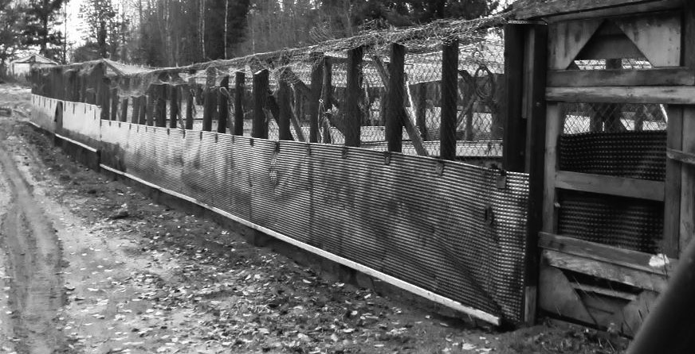

The A-compartments with all their fences were lifted 30 cm off the ground.

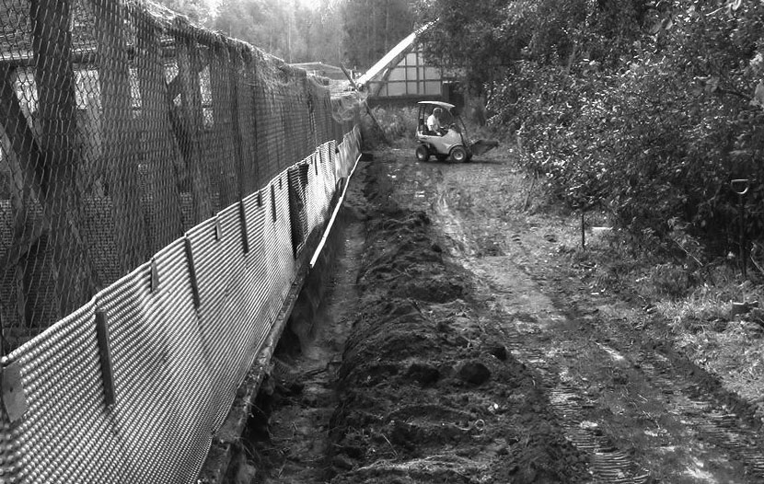

Long ditches had to be dug for the rat nets.
In summer 2015 we had no rat problem in the A breeding area. Sadly, it will take time until we can afford to do the same thing in area B. Unless, unexpectedly, our Ministry begins to restore the favorable conservation status of the Lesser White-fronted Goose in Finland.

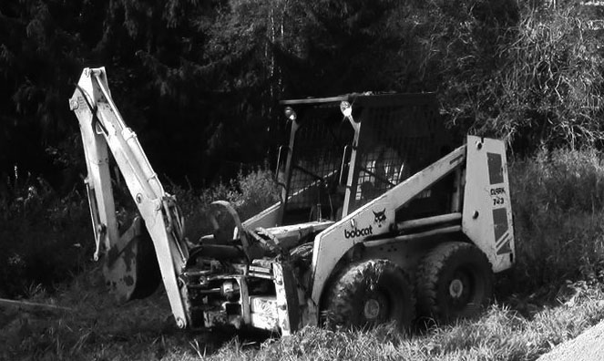

The Bobcat-excavator was able to dig close to and even under the fence.

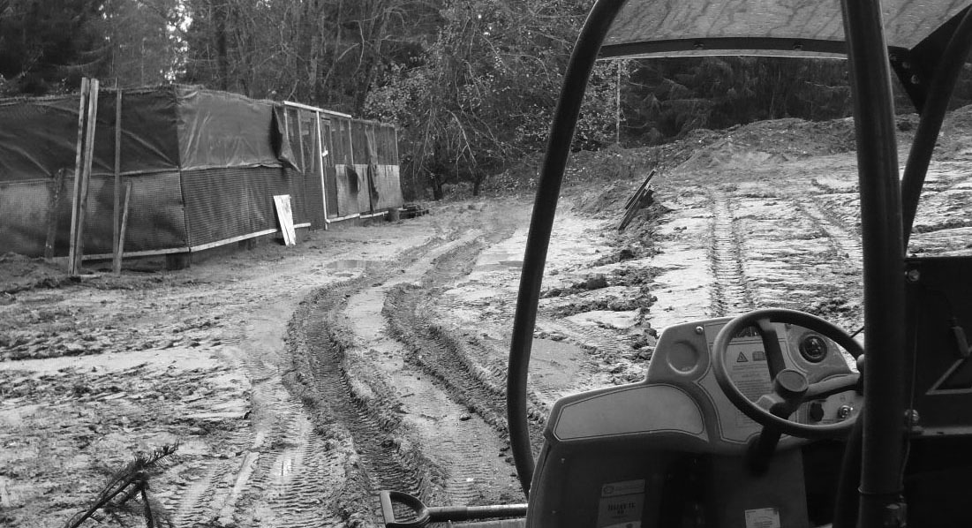

The heavy machines destroyed vegetation around the breeding area. Autumn rains made things worse. For some time not even the food to the Geese was delivered over the muddy area by tractor.
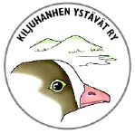

Friends of the LWfG - Report 2013-2014

The annual meetings 2013 and 2014
Formally, the Friends’ annual meetings should be held early in the year. The meeting 2013 was held 16.5.2013 in Chairman Antti Haapanen’s Summer Home in Valkeakoski, Finland. In 2014 he invited all members again, but because of a medical disorder that meeting was unfortunately cancelled one day before the date. The meeting was held in December 2014, when he was completely fine again.
In spite of the regrettable delay, both meetings could be held formally correctly and could make the mandatory decisions. The annual reports and formal plans for coming years were signed. The money accounts showed a total negative result of about 100€ for 2012 and a 600€ profit for 2013. Member fees were held at the current 50 € or 8 working hours. Most of the funds for running the Goose farm come from donations, together with the fees adding up to about 7 000 € annually. The volunteers’ work is not included in this number. In particular the breeder Pentti Alho himself charges very moderately, if at all, for his work.
The import of Geese was delayed until the courts gives green light. To improve breeding results, money was reserved for a major overhaul of the A-series breeding compartments.
The board was re-elected in both meetings. The board members are: Antti Haapanen (Chairman), Erkki Jaanu, Lauri Kahanpää, Erkki Kellomäki and Eero Peltonen. Deputy members are Jyrki Patomäki, Pekka Ruokonen and Jouni Riihimäki. Kirsti Krogerus continues as auditor. After the annual meetings, the board elected Erkki Jaanu as vice Chairman and Lauri Kahanpää as secretary. Ari Lehtonen was nominated treasurer. The Friends’ board meets only a few times a year. Practical decisions are usually made informally in connection with work sessions at the farm and/or by phone and confirmed by e- mail.

Activities in 2012 and 2013
Not all activity reports of the Friends are translated into English. The last report was published in the Finnish language Bulletin number 3 / 2011. Neither the Friends’ goals nor the methods to reach these goals have changed very much in the years. That is why the Reports do not change very much from one year to another: The birds and buildings are taken care of. Money is needed. Information is spread both in and outside Finland. There is cooperation with domestic and foreign organizations. Both Finns and Dutch members observe free-living Lesser White-fronted Geese in the Netherlands. Information comes from our Friends in many countries like Sweden, Germany, Russia Kazakhstan and Iran. Let us list some more random details:
- The Friends’ register counts a little more than fifty members, many academic biologists, among them more than ten foreign experts.
- The Bulletin appears (too) irregularly. All are still available on the net, many also on paper. They are listed in this issue.
- Although cooperation with Jyväskylä University was successful, the NGO has only once hired a biology student as paid help in spring when there is extra much workload during nesting. The cost was too high and volunteers could take care of the birds.
- The Friends of the LWfG continues to be a partner of the international project Aktion Zwerggans - Operation Fjällgås. The Project has a surplus of LWfG goslings. Some of them could possibly be imported to Finland.
Still a disproportionate share of work has to be spent on writing letters to various authorities in Finland and in judicial processes to explain the need and the government’s obligation to restore the favourable conservation status of the Lesser White-fronted Goose in Finland.
In daily practise, most efforts of the Friends concentrate around managing the ex-situ population of the LWfG in Finland. Managing the breeding site is described in detail above. Releases of LWfG in Finnish Nature suffer from the current juridical situation. There are legal decisions both allowing and forbidding releases, and the supreme (civil) court has not taken up the matter. (In 2014 the Friends appealed to the European Union.)
The Friends of the LWfG are also active in science. In 2012 the idea was born to relate the breeding results of the LWfG in Norway with the Lemming years. We had the need to find something to tell at the GOOSE conference in France and it seemed easy to check whether the LWfG in Norway behaved much like the Barnacle Geese in Russia. It is commonly known that Barnacle Geese may not even breed in the worst predator years after a Lemming maximum. The LWfG data is easily accessible in the net on the Norwegian ”Piskulka” page (Thank You, NoF and WWF). To find reliable data on the Lemmings was more difficult but possible (Thank You, prof. Heikki Henttonen). The result of the analysis was surprisingly clear: The current increase of LWfG numbers in Norway is totally explained by the recent strong Lemming years. The effect of other factors like conservation measures on the migration routes is invisible. Falling ill at the time of the conference prevented the Friends from giving the talk at the meeting in Arcachon, France, but the contents of the talk were published in the GOOSE BULLETIN No 16. 2013. A preprint on the findings also appeared in this Bulletin’s issue 2/2013.

Juridical activities in 2014
The updating of the series A breeding compartments was not the only highlight of the Friend’s activity in 2014. The other was the partial success in the on going suite of legal processes: the supreme administrative court of Finland declared that the Friends’ attempt to import of LWfG had been stopped on dubious premises and that that Finnish officials had made mistakes. The case was sent back to the first office for re-examination. The court had to vote before this decision; the President of the court defended the opinion that there is no reason at all for a new examination but an import licence should be granted immediately. For clarity, we have asked for a new import licence, even though the original Russian-German birds are lost.

The LWfG Bulletin

The first LWfG Bulletin appeared in 2001. Since then 40 issues have come, all both in print and in the net (html or Word/doc, special issues in pdf. The URL address is http://www.ansererythropus.tk). Most are in Finnish, many are English translations, a few even English originals. Below is a list of them all. Remaining paper versions can be ordered for free, we only charge the shipping fees. Our web page contains a full index of all issues

 | Finnish | English | remaining
2001 | 1 |  | -
2002 | 1, 2 | 1E, 2E | -
2003 | 1, 2 | 1E, 2E | -
2004 | 2 | 1 (Special), 2E | 2
2005 | 1, 2 | 1E | 1
2006 | 1 | - | -
2007 | 1, 2, 4 | 3 | 1, 2, 3, 4
2008 | 1 (Suunn.), 2, 3 | 4 | 1,3,4
2009 | 2 (Esite), 3 | 1 (Plan), 4 | 1, 2, 3
2010 | 1, 3 | 2 (Brochure), 4 | 1, 3, 4
2011 | 1, 2, 3 | - | 1, 2, 3
2012 | - | - | -
2013 | 1 | 2 | 1
2014 | 1, 2 | 1 | 1, 2
2015 |  | 1 | 1

Number 1/2009, the English original version of “the Plan to Restore the Favorable Conservation Status of the Lesser White-fronted Goose in Finland”, is in good supply and is still worth while to order and read although an updated version is going to appear soon.

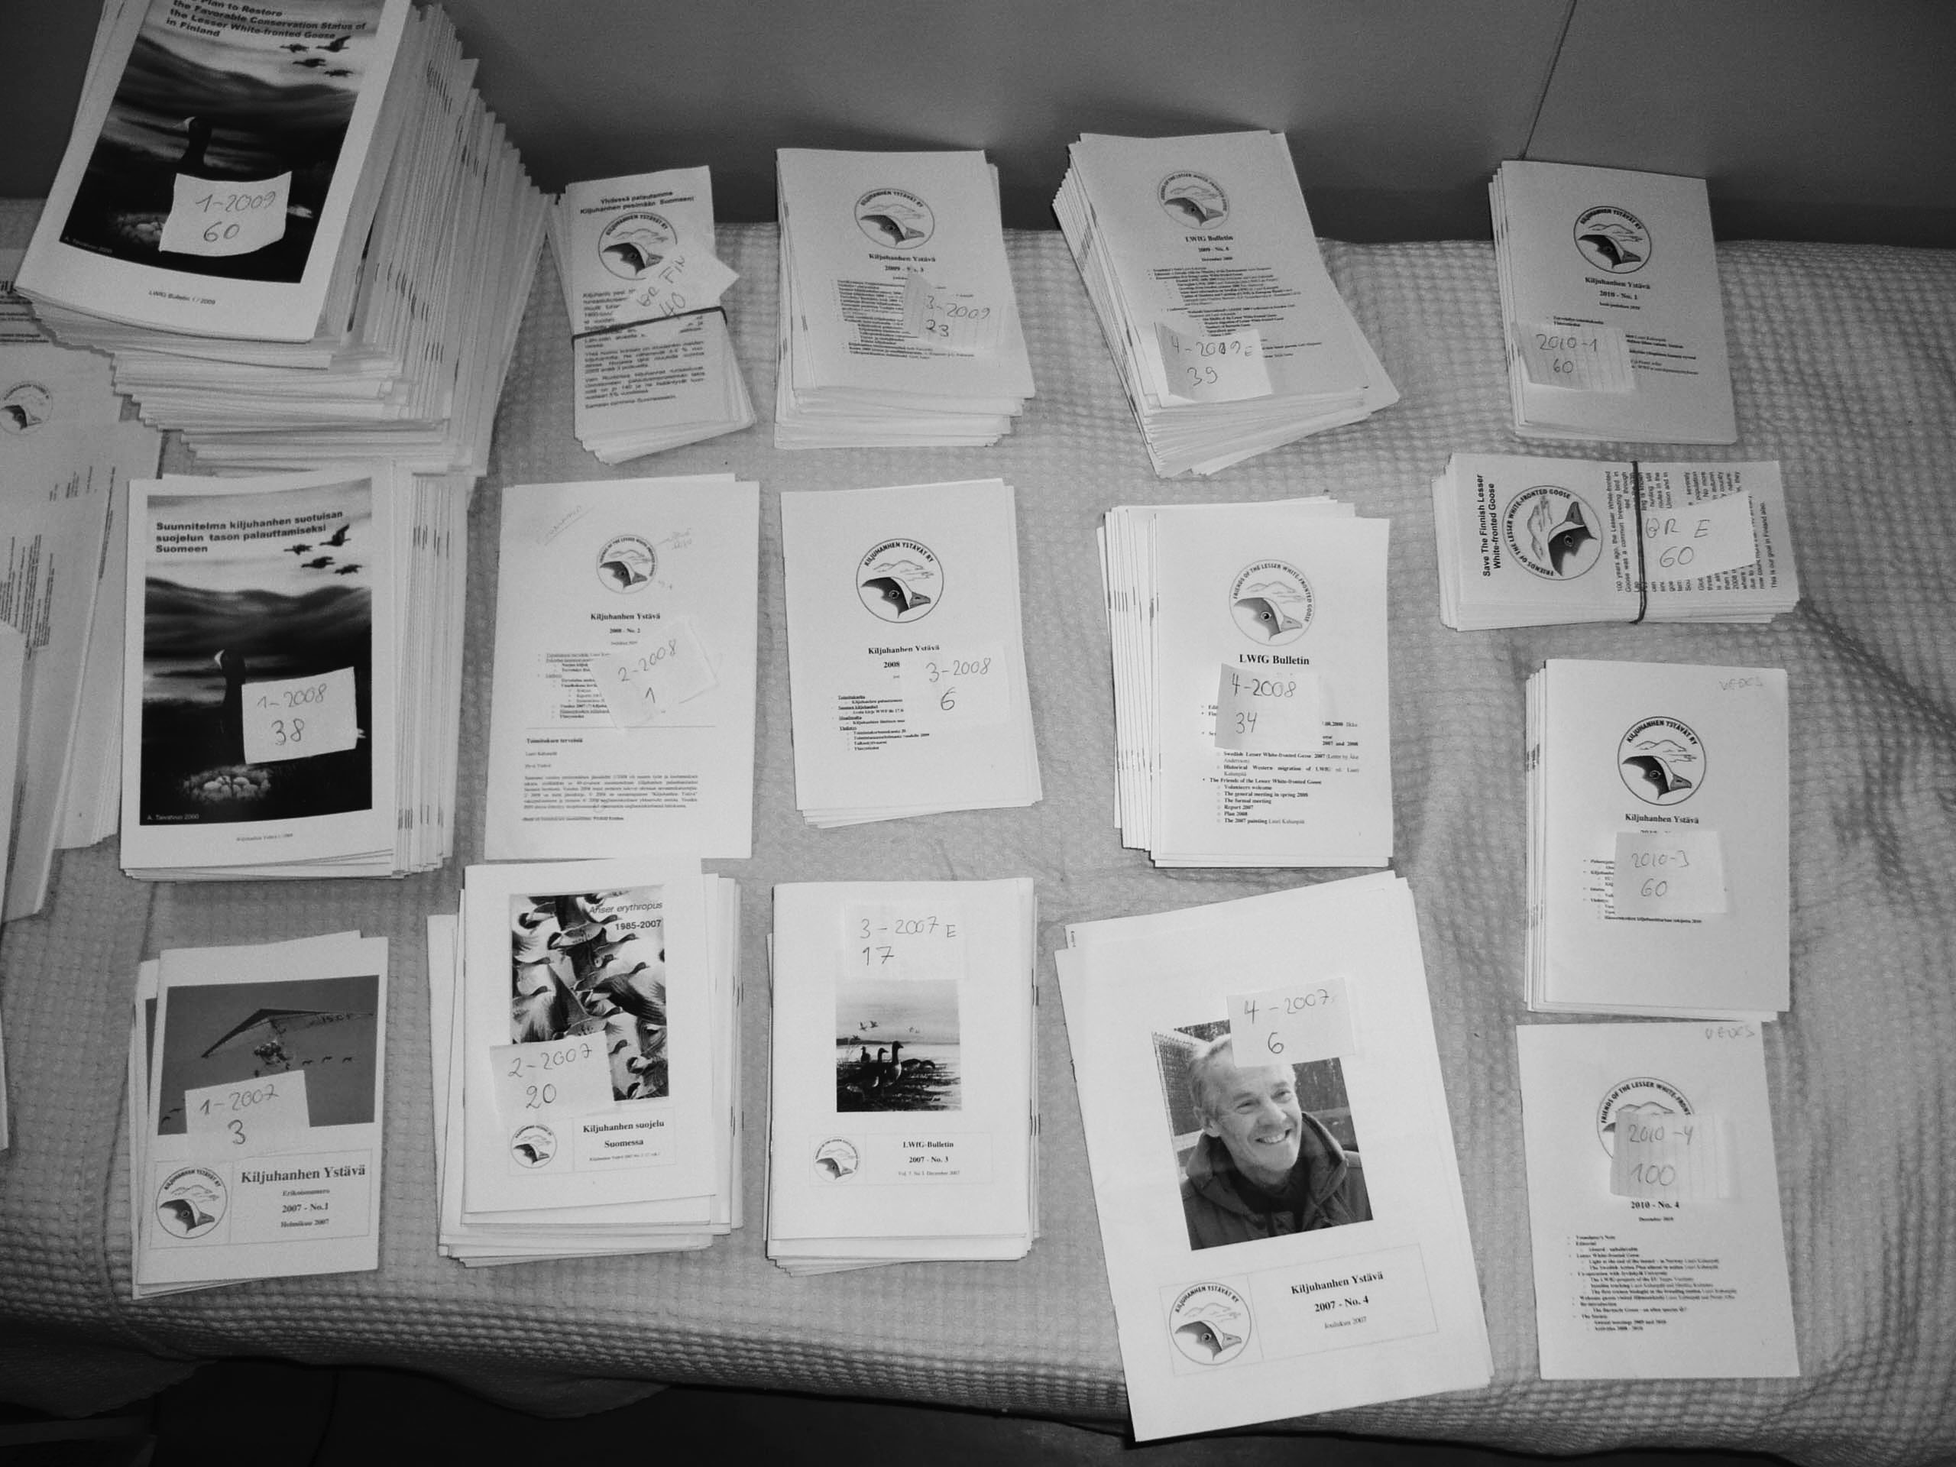

Remaining issues can be ordered for free

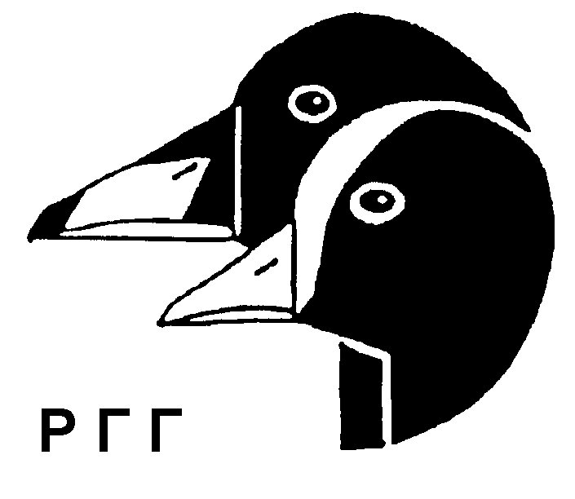
In addition to the LWfG Bulletin we also distribute some copies of the Russian Casarca journal. Casarca is published in Moscow by the RGG also known as the Goose and Swan Study Group of Eastern Europe and North Asia. (See Bulletin 2003/1). Casarca has good English Abstracts of most papers

ISSN-L 1798-0437
ISSN 1798-0437

